8 February 2026 Psalter 1
OUR LADY OF LOURDES AND SAINT CECILIA
Priest in charge: Father Donald Nwaka
Landline: 01258 452051 Mobile: 07931939907
Newsletter: newsletterblandfordcatholics@yahoo.co.uk Website: blandfordcatholics.org
Plymouth Diocesan Trust Registered Charity No. 213227
Hospital RC Chaplains: Dorchester 01305 255198 / Poole: Deacon Declan McConville 01202 442167

MASS INFORMATION FOR THIS WEEK IS CORRECT AT TIME OF PUBLISHING BUT MAY BE SUBJECT TO CHANGE AT SHORT NOTICE
Saturday 7 February No Exposition or Confessions
5.30 pm VIGIL MASS OF SUNDAY
Sunday 8 February 9 am HOLY MASS
DAY FOR VICTIMS OF HUMAN TRAFFICKING
& THOSE WHO WORK TO COMBAT IT
FIFTH WEEK IN ORDINARY TIME (A2)
Monday 9 February 9.10am Morning Prayer NO MASS
Holy Rosary, Divine Mercy Chaplet, and Prayer Cenacle
Tuesday 10 February NO Evening Prayer NO MASS
St Scholastica Mem
Wednesday 11 February 9.10am Morning Prayer 9.30 am HOLY MASS
OUR LADY OF LOURDES FEAST WORLD DAY FOR THE SICK
Thursday 12 February 9.10am Morning Prayer 9.30 am HOLY MASS
Friday 13 February 9.10am Morning Prayer 9.30 am HOLY MASS
Saturday 14 February 9.30am Exposition of the Blessed Sacrament and Confessions
10.00am HOLY MASS in thanksgiving for Rome Pilgrimage
St Cyril, Monk & St Methodius Bp FEAST
MISSIONARIES & PATRONS OF EUROPE
5.30 pm VIGIL MASS OF SUNDAY
Sunday 15 February 9 am HOLY MASS
DAY FOR THE UNEMPLOYED

Please welcome Father Antony Pennicot who will be celebrating Masses this weekend. Thank you very much Father.
Fr Donald is expected to return soon and that there will be Holy Mass on our Patronal Feast Day.
Please pray for the repose of the soul of David Cowgill, and for Gabriele and their children at this very difficult time for them.
Please keep in your prayers: Father Robert; Father Jon Bielawski; Christina and John Morley; Janet Hudson; Josie Seath; Barbara Emery; Teresa and Tom Hogan; Bernard Nertney (Teresa's brother); and all those suffering at this time.
POPE'S INTENTION for FEBRUARY 2026
FOR CHILDREN WITH INCURABLE DISEASES

Let us pray that children suffering from incurable diseases and their families receive the necessary medical care and support, never losing strength and hope.

This Sunday, 8 February, is dedicated to the Victims of Human Trafficking & Those Who Work To Combat It and we pray:
- For those who have suffered as a result of human trafficking through being bought, sold, transported into slavery for sexual exploitation, domestic servitude and forced labour.
- For those who offer pastoral support to victims who have suffered psychological damage from their traumatic experiences.
- For all agencies working in collaboration to combat human trafficking.
This Wednesday, 11 February, our Patronal Feast Day, is the World Day for the Sick and we pray:
- For all who are sick; may they be restored to fullness of health or come to know dignity in their suffering.
- For doctors, nurses and all who care for the sick and the dying; may they bring Christ’s love and compassion to all whom they care for.
BASIC INSTRUCTION

Q: What is the third article of the Creed?
A: The third article of the Creed is 'who was conceived by the Holy Spirit, born of the Virgin Mary'.

COLLECTIONS |  | SPECIAL COLLECTION
24 / 25 Jan  31 Jan / 1 Feb | £249.10  £221.66 | White Flower Appeal (SPUC) £372.18  Racial Justice £107.05
Thank you to everyone who contributed.

ROTAS for READERS & COUNTERS are displayed in the church hall.

D A T E S F O R Y O U R D I A R Y
9 February: Cenacle Prayer Group every Monday after Rosary and Divine Mercy Chaplet
10 February: Knit and Natter 2 - 4pm in the Hall - all welcome
11 February: Feast Day of Our Lady of Lourdes
11 February: RCIA, 7-9 pm - all welcome
14 February: Thanksgiving Mass for Rome Pilgrimage, 10 am
18 February: Ash Wednesday - Lent begins
21 February: Our Lady of Lourdes Parish Lunch (Feast Day 11 February) - more details below
28 February: Lent Lunch in the Hall

PARISH LUNCH - Saturday 21 February at Stourpaine Village Hall - Tickets on sale after the weekend Masses for a further two weeks. If you intend attending the lunch, but have not yet added your name to the list at the back of the church (irrespective of whether you have already bought a ticket), please do so, in order that the caterers may plan around the number of people attending.
LENT LUNCHES Ash Wednesday is 18 February and during Lent we try to come together on Saturdays for a simple lunch of soup and bread, in solidarity with those around the world who may not know where their next meal is coming from, and to raise money for CAFOD who are working with vulnerable communities to help in emergencies and to support longer term projects. Our first Lent Lunch 2026 will be in the hall on Saturday 28 February, hosted by Anna and Ali. If you are willing to host a lunch either in your home or in the hall on one of the other Saturdays in Lent (7/14/21/28 March), please add your name to the sign-up sheet at the back of church.
KNIT AND NATTER: We meet every week on Tuesday afternoons (2 - 4pm) in the Hall unless otherwise notified. You are most welcome - even if you aren't a "Knitter" come for a "Natter"!

NOURISH (Blandford Food Bank) New requests for this month: cereal, deodorant, jam/marmalade, UHT milk, and tinned foods - rice pudding, carrots, fruit, meat. Thank you very much for your help. Jan
DAN MURPHY, PARISH SECRETARY The best way to get in touch with me is by email: blandford@prcdtr.org.uk which I monitor daily. Alternatively, look out for me at Mass, or write to me at the Presbytery (but this is the slowest method of contact). Dan

"I have consecrated this temple which you have built: I confer my name upon it for ever, and my eyes and my heart shall be there always." (I Kings 9:3)
In no other spot as much as Lourdes do we feel so impelled toward prayer, forgetfulness of self, and charity. The most fervent are attracted to a life more totally offered to God's service. The less fervent become aware of their tepidity and rediscover the way of prayer. Hardened sinners and unbelievers are often touched by grace. - Pope Pius XII

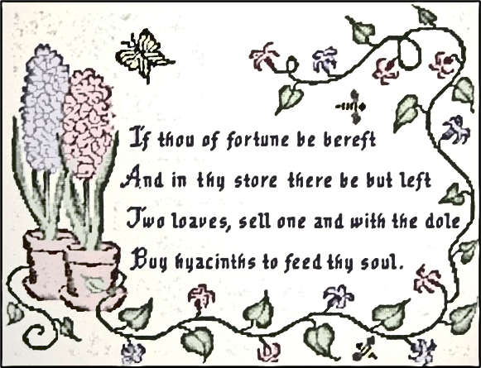

Saadi Shirazi (c1209-1291)
tr. John Greenleaf Whittier

