7 December 2025 YEAR A2

OUR LADY OF LOURDES AND SAINT CECILIA
Priest in charge: Father Donald Nwaka
Landline: 01258 452051 Mobile: 07931939907
Newsletter: newsletterblandfordcatholics@yahoo.co.uk Website: blandfordcatholics.org
Plymouth Diocesan Trust Registered Charity No. 213227
Hospital RC Chaplains: Dorchester 01305 255198 / Poole: Deacon Declan McConville 01202 442167

MASS INFORMATION FOR THIS WEEK IS CORRECT AT TIME OF PUBLISHING
BUT MAY BE SUBJECT TO CHANGE AT SHORT NOTICE
Saturday 6 December 9.30am Exposition of the Blessed Sacrament & Confession
10am HOLY MASS
followed by Meeting of The Family of Mary St Nicholas Bp (died c350) Opt Mem
(Patron of Russia, sailors, pawnbrokers and children)
5.30pmVIGIL MASS OF SUNDAY

SECOND WEEK OF ADVENT (YEAR A)
Sunday 7 December 9.00am CHILDREN'S MASS
SECOND SUNDAY OF ADVENT
Monday 8 December 11am HOLY MASS
followed by Holy Rosary, Divine Mercy Chaplet, Prayer Cenacle
THE IMMACULATE CONCEPTION OF THE BLESSED VIRGIN MARY SOL
Tuesday 9 December 6.10pm Evening Prayers 6.30pm HOLY MASS
St Juan Diego Cuauhtlatoatzin Opt Mem
Wednesday 10 December 9.10am Morning Prayers, 9.30am HOLY MASS
Our Lady of Loreto Opt Mem
Thursday 11 December 9.10am Morning Prayers 9.30am HOLY MASS St Damasus I Pp (c305-384) Opt Mem
Friday 12 December 9.10am Morning Prayers 9.30am HOLY MASS
followed by Benediction
Our Lady of Guadalupe
Patron of the Americas
Saturday 13 December 9.30am Exposition of the Blessed Sacrament & Confession St Lucy VM (died c304) Mem
5.30pm VIGIL MASS OF SUNDAY
Sunday 14 December 9.00am HOLY MASS
THIRD SUNDAY OF ADVENT

Please keep in your prayers: Father Robert; Father Jon Bielawski; Christina & John Morley; Janet Hudson; Josie Seath; Barbara Emery; Teresa & Tom Hogan; Bernard Nertney (Teresa's brother); and all those suffering at this time.

LETTER FROM FATHER DONALD
-=-=-=-=-=-=-=-=-

- The Solemnity of the Immaculate Conception is on Monday 8 December. Mass will be at 11am that day - it will be a requiem mass for the repose of the soul of James Mackenzie. There will be a reception in the Hall and we are invited by the family members to join them.
- Please pray for the soul of Colin Rolls, a one-time member of our parish, who died recently. You may remember Colin as chair of the finance Committee for many years and also for the maintenance of the church premises. As chair he negotiated with Bryanston Estates, then owners of the land to the Side of the church, for a formal agreement for cars to be parked in the lane during services and for the sale of part of the church garden which raised money and partly funded the building of the hall. May he rest in peace. We encourage those who knew him to please reach out to the family on behalf of the parish.
- Let us pray for Anthony in his formation to the Diaconate. As part of his preparation, he will occasionally give a commentary (of about 5 minutes) during Exposition of the Blessed Sacrament before Sunday Mass. He will also be away more often, so he and I (and our supply priest in my absence) will agree on the schedule.
- Dedication of the new church in Gillingham will take place on 9 December at 12noon. If you have never experienced such a rare occasion, I especially encourage you to attend. Please note that a high turn-out is expected and Marnhull/Gillingham parishioners have been asked to sign-up, so it will be helpful if we would also do so. This will help Fr Cletus know about attendance and for refreshments afterwards.
- Timings for Christmas activities and services will be included in next week's Newsletter. Please note that the Penitential Service has had to be cancelled - it will be replaced by Christmas confessions.
- Our parish finance council is made up of the priest, Fr Donald Nwaka, the Parish secretary, Dan Murphy, and the parish treasurer, Andrew Traynor, together with Helen Greaser who is in the advisory council and the parish finance council. In the absence of the priest, the secretary and treasurer can sign cheques for previously-agreed expenditure. We thank the former finance committee members for their shadowing roles so far in supporting the new finance council members.
- This week, I would like to thank several people for their support to the parish:
  - All those who have prepared the children for mass
  - All those who helped to tidy up and re-light the Marian Grotto
  - All those who support Dinesh by making cakes for the first Sundays of the month
  - All those who have piloted the parish RCIA so well
  - Our hard-working newsletter coordinators
God bless you all!

BASIC INSTRUCTION
Q: Which person of the Blessed Trinity is Jesus Christ?
A: Jesus Christ is the Second Person of the Blessed Trinity.

POINTS TO PONDER

- Do you know that in the day of the Lord, justice shall flourish, and great peace forever?
- Do you know that the day of the Lord comes with tranquility, unity and peace in the world. "The wolf shall dwell with the lamb, the leopard shall lie down with the kid, and the calf and the lion and the fatling together...".
- Do you know that how best to prepare for the day of the Lord is by "Metanoia" - "a repentant heart".
- We prepare the way of the Lord, make his paths straight, by getting rid of hypocrisy, jealousy, slander, back-biting and envy.
- We should be like John the Baptist who prepared a way for the coming of Christ by humbling himself.

With blessings on every one of our Parish family,
Father Donald

COLLECTIONS | WEEKLY OFFERINGS | SPECIAL COLLECTION
29/30 November | £299.62 | n/a
Thank you to everyone who contributed.

ROTAS for READERS, SACRISTANS & COUNTERS are displayed in the church hall.
D A T E S F O R Y O U R D I A R Y
6 December: Family of Mary Meeting following Mass
7 December: Cake Sale after Sunday Mass
8 December: Cenacle Prayer Group- now every Monday after Rosary & Divine Mercy Chaplet
9 December: Dedication of new parish church in Gillingham at 12noon
10 December: Rite of Christian Initiation for Adults (RCIA), 7-9 pm
21 February 2026: Our Lady of Lourdes Parish Lunch (Feast Day 11 February)
27-30 April 2026: Parish Pilgrimage to Walsingham
N O T I C E S
CHILDREN'S CHRISTMAS EVE MASS
As usual, the first mass of Christmas (usually at 6pm - tbc) is a children's mass. The children will enact the gospel story and there are speaking and non-speaking roles for children. Any children who wish to be involved in this, please stay behind after mass this Sunday 7 December or let Ali know via alisoncain@gmail.com - thanks. Ali
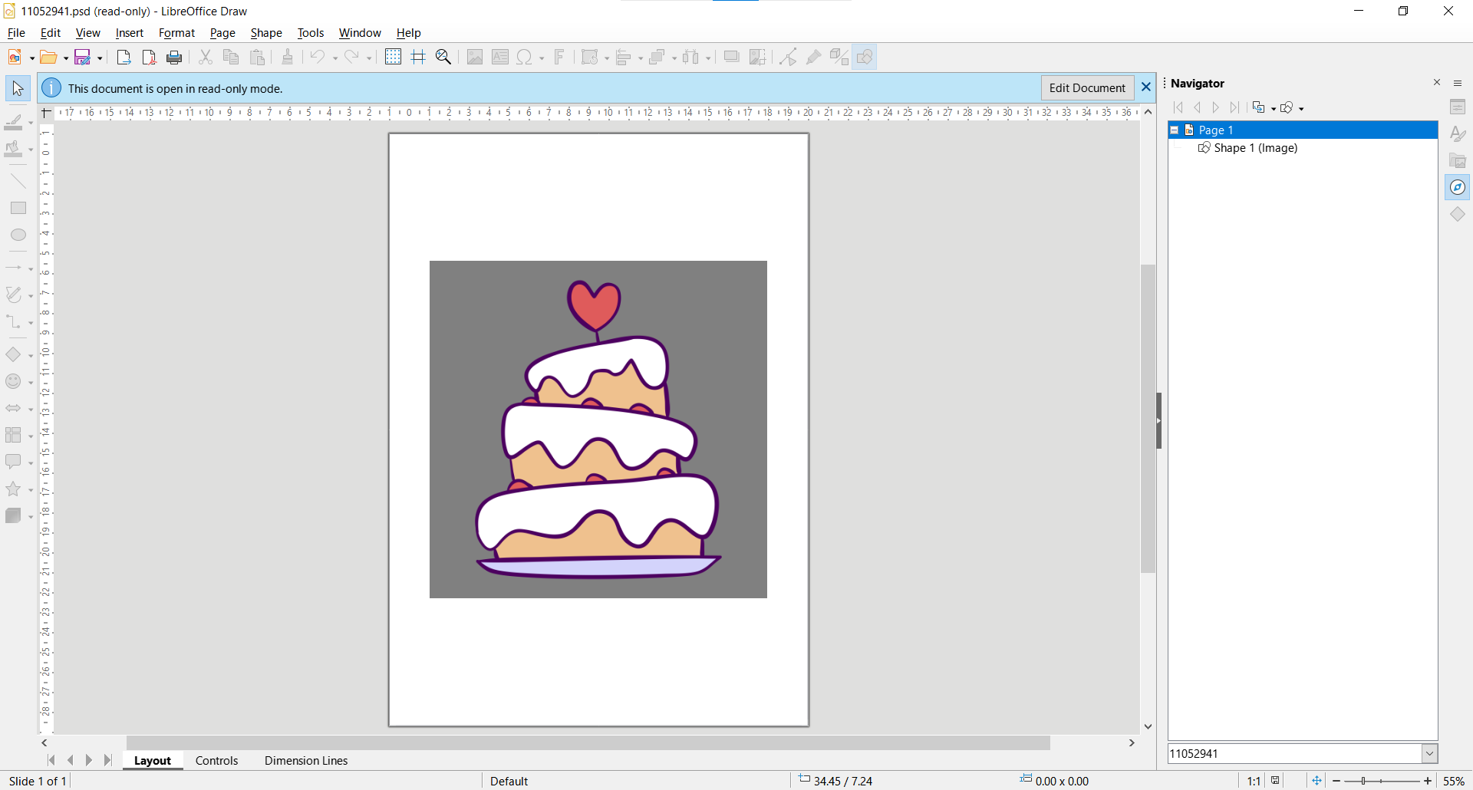
CAKE SALE after Mass this Sunday 7 December. We are looking forward to our bakers' delicious cakes. Proceeds will go towards helping Dinesh.
RITE OF CHRISTIAN INITIATION FOR ADULTS (RCIA) is held weekly on Wednesdays (7 to 9pm) - next meeting 10 December. Everyone is invited to come to the course: those exploring the faith, the lapsed who wish to return, those wishing to understand their faith more deeply, and those who support the course in testimony of their faith to help others.
MINISTERS OF THE WORD More Readers are required for the Saturday evening Vigil Mass. If you are interested in having some guidance before you commit to adding your name to the Rota, please attend church at 4.30pm on Saturday 13 December. Ruth
NEW DAILY MISSAL - there is an Erratum addendum to the Missal. Please collect an envelope at the back of the church if you ordered a new Daily Missal. Ruth
CHRISTMAS CARDS have now sold out - thanks for your support. E dward & Frances
NOURISH (Blandford Food Bank) The Christmas Appeal collection date has now passed, but please do donate festive and/or ordinary items, as these are still very much needed. Please put them in the green box at the back of church. Many thanks! Jan
BIDDING PRAYERS ROTA 2026 We have a monthly rota for Bidding Prayers that starts at the beginning of the calendar year. Each person on the rota prepares the Bidding Prayers for the Saturdays/Sundays within their allocated month. If you would like to participate and join the rota, please speak with Fr Donald or Marie Fisher (mob: 07712 108916). Marie

BONIFACE IS HAPPY! Your donations have been counted and we have raised £286. Well done and, on behalf of Jackline, "Thank you". Frances
ITEMS FREE TO A GOOD HOME! If you would like to have the spare bed and/or fridge from the presbytery, please let Father Donald know. Also, please do feel free to go and take apples from the garden.
PARISH VOLUNTEERS We are still looking for more voluntary helpers for the parish, so please speak to Fr Donald or Andrew or Dan if you can help, particularly in the following areas:
Electrician/lighting | General labour/maintenance/odd jobs
Updating/repainting the parish roadside sign (by the hedge)
Helping Molly with tea and coffee on Sundays, in the absence of Julie
COUNTING The counting of the weekly giving takes place after Mass on Sunday. I have offered to continue with the Rota which is now being prepared for the first 6 months of 2026. It is good to have an even number of counters so you can be paired with the same person each week (unless personal commitments intervene). If you would like to join the Rota, please speak to me, Father Donald or another member of the Rota (see list in the hall). New counters will be paired with an experienced person in order to know the procedures. Ruth

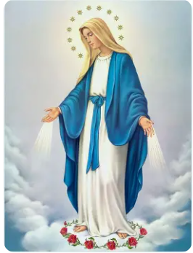
ARTSREACH, Dorset's rural arts charity is supporting a performance by the BSO Brass Ensemble on Tuesday 16 December at 7.30pm in Blandford Parish Church, Market Place. Their Winter Fanfare is a heart-warming festive programme, including beloved traditional pieces such as the Coventry Carol, the March from Tchaikovsky’s Nutcracker and We Three Kings, plus classics like Santa Claus is Coming to Town, Have Yourself a Merry Little Christmas and the rousing favourite Fairytale of New York. Tickets are £14.00 (adults), £6 (under 18s), £36 (family) and are available from www.artsreach.co.uk or 07729 786600.
The Immaculate Conception is the name that reveals with precision who Mary is.
Mary is profoundly holy in the totality of her existence, from her very beginnings.
Pope John Paul II

