**SUNDAY 5 January 2024 YEAR C PSALTER 2/PROPER**

**OUR LADY OF LOURDES AND SAINT CECILIA**

**Priest in charge: Father Donald Nwaka**

**Landline: 01258 452051 Mobile: 07931939907**

**Hospital RC Chaplains: Dorchester:** 01305 255198;

**Poole:** Deacon Declan McConville 01202 442167

Newsletter: newsletterblandfordcatholics@yahoo.co.uk

Website: blandfordcatholics.org

Plymouth Diocesan Trust Registered Charity No. 213227

**Please keep in your prayers: Father Robert; Christina and John Morley; Janet Hudson; Josie Seath; Father Chacko; Theresa and Tom Hogan and Sandra and Sharon; Kelly Harte; Joan Pitman; and all those suffering at this time.**

**MASS INFORMATION FOR THIS WEEK IS CORRECT AT TIME OF PUBLISHING BUT MAY BE SUBJECT TO CHANGE AT SHORT NOTICE**

**Saturday 4 January 9.00am Exposition of the Blessed Sacrament**

**9.30am Confessions**

**10am HOLY MASS (Family of Mary) *followed by* FoM Meeting**

**5.30pm VIGIL OF THE EPIPHANY (OBL SOL)**

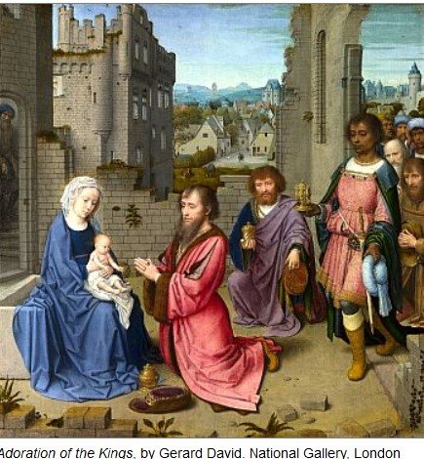

**Sunday 5 January THE EPIPHANY OF THE LORD (OBL SOL)**

***8.30am Exposition of the Blessed Sacrament***

**9.00am CHILDREN'S MASS**

**Monday 6 January 9.10am Morning Prayers *followed by* 9.30am Liturgy of the Word and Holy Communion,Holy Rosary, *and then* Divine Mercy Prayer Group**

**Tuesday 7 January St Raymond of Peñafort (Opt Mem)**

**6.10pm Evening Prayers**

**6.30pm HOLY MASS**

**Wednesday 8 January 9.10am Morning Prayers**

**9.30am HOLY MASS**

**Thursday 9 January 9.10am Morning Prayers**

**9.30am HOLY MASS**

**2.30pm Our Lady's Prayer Group and Bible Study**

**Friday 10 January 9.10am Morning Prayers**

**9.30 HOLY MASS f*ollowed by* Benediction**

**Saturday 11 January 9.00am Exposition of the Blessed Sacrament**

**9.30am Confessions**

**5.30pm Vigil Mass of Sunday**

**Sunday 12 January BAPTISM OF THE LORD (FEAST)**

***8.30am Exposition of the Blessed Sacrament***

**9.00am HOLY MASS**

**WEEKLY OFFERINGS** - £274.81. Thanks to all who contributed. **FLOWER COLLECTION BOX** - The wall box near the side door is for donations for flowers. The contents were counted last week £50.80 has been donated. Thank you. **CATHOLIC CHILDREN'S SOCIETY** - The basket at the crib is for donations to the Catholic Children’s Society. **STATIONS OF THE CROSS LENT 2024** - At the last Finance Meeting it was decided to send the money collected during the Friday Stations of the Cross to the Blandford Food Bank, now known as Nourish. If anyone objects to this decision will you please speak to me. *Ruth Hiscock* Parish Treasurer

With blessings on every one of our Parish family,

**Father Francis**

Welcome to Father Francis and thank you for looking after us in Father Donald's absence.

**ANY OTHER BUSINESS**

**\*\* WILL PARISHIONERS WISHING TO INSERT NOTICES PLEASE EMAIL THEM IN NO LATER THAN THURSDAY EVENINGS OR THEY MAY NOT BE RECEIVED IN TIME FOR PRINTING ON FRIDAY**

**MORNINGS\*\***

**KNIT & NATTER** The group returns on **Tuesday 7th January 2025 2-4pm** in the church hall. All welcome. *Julie*

**SAVE THE DATE:**Day of Reflection – **Saturday 1 February** at **University of Exeter Catholic Chaplaincy.** Have you ever asked the question 'Is God calling me to Priesthood or to the Religious life?'. This **'Day of Reflection' for men** will be held on Saturday 1 February from **10:00 to 16:00** at Exeter University Chaplaincy, Boniface House, Glenthorne Road, Exeter EX4 4QU. Under 18s are welcome to attend with parents’ permission. For more information and to register your interest please contact Fr Jacek Kostuch on [jacek.kostuch@prcdtr.org.uk](mailto:jacek.kostuch@prcdtr.org.uk) or [vocation@prcdtr.org.uk](mailto:vocation@prcdtr.org.uk). *Julie Taylor*, Vicariate for Clergy Administrator

**FORMATION! FR JON BIELAWSKI**  (Department of Evangelisation and Catechesis, Plymouth Diocese) is coming to our Deanery to give a talk entitled 'Simple Proclamation' - how to, in conversation, give shape and meaning to God in Jesus, so that others may know and believe. DATE: **Saturday 1 February, 10.30 am to 12.30 pm at St Catherine's, Lewens Lane, Wimborne**, BH21 1LE.

**GATHER 2025 JUBILATE** A weekend of faith, formation and friendship, **Friday 28th - Sunday 30th March, Livermead Cliff Hotel, Torquay**. Booking forms available from the Sidmouth parish office, see facebook page or email [plymouthgather@yahoo.com](mailto:plymouthgather@yahoo.com) for more information. *Rebecca*, Parish Secretary, Sidmouth

**STAY AWAKE 2025!**  Please save the date: **Saturday 5th April, 2025.** It is for every age group and is such a joy! So, you are being given plenty of notice! *Pippa Worth*

*At the moment when Mary presents her Son to the Magi, she not only performs a personal action as Mother but also acts as the figure of the Church. As the mother of all peoples, the Church in the person of Mary initiates her work of evangelization. -* St John Paul II