**SUNDAY 6 October 2024 YEAR B2: PSALTER WEEK III**

**OUR LADY OF LOURDES AND SAINT CECILIA**

**Priest in charge: Father Donald Nwaka**

**Landline: 01258 452051 Mobile: 07931939907**

**Hospital RC Chaplains: Dorchester:** 01305 255198;

**Poole:** Deacon Declan McConville 01202 442167

Newsletter: newsletterblandfordcatholics@yahoo.co.uk

Website: blandfordcatholics.org

Plymouth Diocesan Trust Registered Charity No. 213227

**Please keep in your prayers: Father Robert; Christina and John Morley; Janet Hudson; Josie Seath; Father Chacko; Sandra; Kelly Harte; and all those suffering at this time.**

**MASS INFORMATION CORRECT AT TIME OF PUBLISHING BUT MAY BE SUBJECT TO CHANGE AT SHORT NOTICE**

***During the month of October, which is dedicated to St Joseph, we will pray one decade of the Holy Rosary after every Mass***

**Saturday 5 October St Maria Faustina Kowalska (Opt Mem)**

**9.30am Confessions**

**10am HOLY MASS (CWL)**

**5.30pm VIGIL MASS OF SUNDAY**

**Sunday 6 October 9am HOLY MASS *followed by* Holy Rosary**

**Monday 7 October Our Lady of the Rosary (Mem)**

**9.10am Morning Prayers *followed by* 9.30am Service of the Word and Holy Communion *and then* Holy Rosary**

**Tuesday 8 October 6.10pm Evening Prayers 6.30pm HOLY MASS**

**Wednesday 9 October St John Henry Newman (Feast)**

**9.10am Morning Prayers 9.30am HOLY MASS**

**Thursday 10 October St Paulinus of York; St Denis & Companions, Martyrs; St John Leonardi and St Paulinus (Opt Mems)**

**9.10am Morning Prayers 9.30am HOLY MASS**

**2.30pm Our Lady's Prayer Group**

**Friday 11 October St John XXIII (Opt Mem)**

**9.10am Morning Prayers 9.30am HOLY MASS**

***including* a decade of the Holy Rosary**

**NO Divine Mercy Prayer Group this week**

**Saturday 12 October St Wilfrid (Opt Mem)**

**9.30am Confessions**

**10am HOLY MASS (CMO)**

**5.30pm VIGIL MASS OF SUNDAY**

**Sunday 13 October TWENTY EIGHTH SUNDAY IN ORDINARY TIME**

**9am HOLY MASS *followed by* Holy Rosary**

We thank Father Tony Pennicott for supplying for us today.

As we receive Andrew into the Catholic faith today, we continue to pray for him and ask God to grant him a deep faith.

After due consultation, we shall have a Mass, accompanied by singing the Liturgy, on 22nd November which is the Feast Day of our Patron Saint, Cecilia.

We continue to ask for the intercession of St Joseph in this month of October which we devote to him.

**OUR NEW SECRETARY** We welcome Harriet who has now started work as our new secretary. **Mass Intention Envelopes** If you are unable to pass these envelopes directly to Harriet, please mark them clearly for her and put in the weekend collection plate.

**DEI VERBUM - THE WORD OF GOD**: “How can we know anything about God with certainty? Why should we trust what the Church tells us about God? How do we make sense of the Bible?” In preparing for the Jubilee year 2025, Pope Francis has asked us to explore the key documents of Vatican II and one of those documents is Dei Verbum. Come and join us with Sister Hyacinthe, who as a Dominican, will guide us through the text and inspire us with a love of God’s Word. Come to Schiller Hall, Buckfast Abbey on Saturday 19th October. The day will take place at **Schiller Hall, Buckfast Abbey on Saturday 19th October** 10am (tea/coffee) 10.30-3pm. (Mass at 12noon) To reserve a place contact: [deborah.vankroonenburg@prcdtr.org.uk](mailto:deborahvankroonenburg@prcdtr.org.uk) *Fr Jon Bielawski* (Delegate for Evangelisation and Catechesis)

**WEEKLY OFFERINGS** £306.75. Thanks to all who contributed. *Ruth*

With blessings on every one of our Parish family,

**Father Donald**

**SAVE THE DATE**: Vocations Retreat 1-2 November Honiton Retreat Centre, St Rita’s Centre, Ottery Moor Lane, Honiton EX14 1AP.

Are you called to witness as a Permanent Deacon, a Religious or a Priest? There is an opportunity to reflect on this with other discerners and others living out vocations as a Permanent Deacon, Religious or Priest. If you are interested please join us at our Reflection Day starting at 5pm on Friday 1 November. Day delegates are welcome to join on Saturday 2 November at 9am.

*For more information and to register your interest please contact Fr Jacek Kostuch on jacek.kostuch*

**DORSET DEANERY JUBILEE BANNER**

We would like to invite people who are thinkers or creative to come together on **Tuesday 15th October 2024** in the church hall here in Blandford from 2-4pm to plan and design our panel on the theme of 'Rest'. We hope that the panels will be created with due regard for care for creation and where possible use donated, recycled and natural materials. The panel will reflect one of the six themes chosen by the Pope and will be joined with panels from across the Deanery to make one banner.

*Pope Francis announced that 2025 will be a year of Jubilee, something which happens every 25 years. The theme is “Pilgrims of Hope” and it will be a year of hope for a world suffering the impacts of war, the ongoing effects of COVID-19 pandemic, and a climate crisis. For more information on the Year of Hope: https://www.cbcew.org.uk/jubilee-2025/ Thank you Teresa*

*https://www.cbcew.org.uk/jubilee-2025/* Thank you Teresa Maguire, Caritas Development Worker, Dorset Deanery  *For further information please contact: julesmulloy@hotmail.co.uk*

**ANY OTHER BUSINESS**

**\*\* WILL PARISHIONERS WISHING TO INSERT NOTICES PLEASE EMAIL THEM IN NO LATER THAN THURSDAY EVENINGS OR THEY MAY NOT BE RECEIVED IN TIME FOR PRINTING ON FRIDAY**

**MORNINGS\*\***

**KNIT AND NATTER**  **next meeting Tuesday 15th October.** Thereafter meetings will continue weekly where possible, on Tuesdays but at irregular intervals and future dates will be announced as soon as possible.  *Julie*

**RIDE AND STRIDE** Thank you to everyone who helped welcome visitors to the church on the day. Richard and I cycled 36 miles and visited 18 churches. Thank you to everyone who sponsored us. I'll be chasing you for money! *Ali*

**CAFOD QUIZ NIGHT** in the church hall on **Saturday 9th November,** hosted by Anthony as quizmaster. Details to follow*.*

**JUBILEE PHOTOGRAPHY PROJECT**  To find out more please follow the link <https://wp.me/paTncV-a2d> *Fran McMullan,* Caritas Project Administrator

**LOCAL ADVENT IGNATION RETREATS,** **MARONITES TALK**, **FRANCISCAN ONLINE WORKSHOPS**, **CARITAS EVENTS**: Please see posters in porch.

**CATHOLIC DIARIES 2025** - If you wish to order a Catholic Diary for 2025 please put your name and colour choice (not guaranteed) on the list at the back of the church. The cost per diary is approx. £6.50. I intend to place the order sometime in October but the final weekend for orders will be in the newsletter. For many years I have ordered these from Buckfast Abbey but have decided this year to support the Shrine Shop in Walsingham. The diaries are the same style and colour choices, and content includes two pages per week, Monthly Planner (one page per month); General Holidays; Church/Special Holidays; Order of Mass. If more than 12 are ordered, post is free. *Ruth Hiscock*

**BLANDFORD FOODBANK (NOURISH)** - We are now a recognised referrer to the Foodbank. So if anyone needs a food parcel, please contact Anthony Reed on 01258 451132 [aprwas@hotmail.com](mailto:aprwas@hotmail.com) or see him after Mass.

The Foodbank, now known as Nourish, provides a wide range of services, help and information; not just the provision of food. The following provides more information:

please google Nourish Community Larder and Food Bank (faith-works.org.uk).  *Anthony*

I am walking 100km over 2 weeks from 7th Oct for the British charity Medical Aid for Palestinians (MAP) with my poor old dog Newton (12, but still full of energy). MAP provides urgent medical supplies, support and healthcare services in the occupied Palestinian territories and Palestinian refugee camps in Lebanon. Unfortunately, over 885 healthcare workers have been killed in Gaza and the West Bank since October 7th 2023 (UN OHCHR report 24/9/24), including doctors and healthcare workers supported by MAP. Despite enormous challenges, including damaged health infrastructure, a lack of fuel for the movement of vehicles for vaccination teams, a shortage of medical supplies, and security risks, MAP remains committed to supporting Palestinian children and their families. Thank you, *Rachel Plummer*

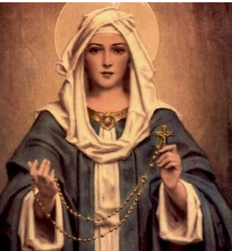

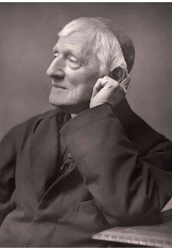

Our Lady of the Rosary, Feast Day 7th October

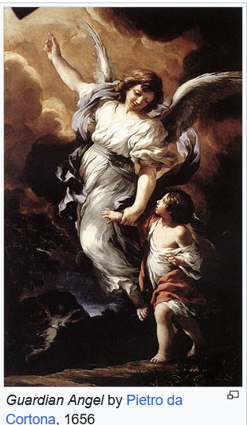

St John Henry Newman, Feast Day 9th October

I apologize for 'demoting' the Archangels to Guardian Angels last week.

The picture represented was of St Michael, in armour, who fights evil and protects us; St Raphael, the Healer, shown with Tobias and his dog and carrying a fish which would be used to heal his father Tobit of blindness (from the Book of Tobit in the Bible); and St Gabriel, the Messenger, who came to announce to Mary the coming of her Son, Jesus Christ. Their feast day is 29th September which fell last Sunday so was superceded by the Sunday Mass. Despite my error, we well celebrated our Guardian Angels on their feast day, 2nd October.