Sunday 4 JUNE 2023 Psalter: Week I

OUR LADY OF LOURDES AND SAINT CECILIA
Parish Administrator: Mgr Francis Jamieson
Landline: 01258 452051 Mobile: 07826 732493

Hospital RC Chaplains:
Dorchester: Fr Barry Hallett 01305 255198; Poole: Deacon Declan McConville 01202 442167 Newsletter: newsletterblandfordcatholics@yahoo.co.uk
Website: blandfordcatholics.org
Plymouth Diocesan Trust Registered Charity No. 213227

Please keep in your prayers: Father Robert; Ruby Cooper, Iris Bell; Christopher; Noreen Breadmore; Christina and John Morley; Leeah, Marjorie’s daughter; Sandra, Teresa and Tom’s niece; Father Tom, and all at the Care Home where he is chaplain; and all families of those suffering at this time.

MASS INFORMATION CORRECT AT TIME OF PUBLISHING BUT MAY BE SUBJECT TO CHANGE AT SHORT NOTICE

ORDINARY TIME YEAR 1

Saturday June 3 NO Latin MASS St Charles Lwanga and Companions, Martyrs (Mem)
5.30 pm Vigil Mass of Sunday
SUNDAY June 4 THE MOST HOLY TRINITY
9.00am HOLY MASS
Monday June 5 St Boniface, Missionary and Martyr (Mem), Patron of the Diocese
9.10am Morning Prayers 9.30am HOLY MASS
Tuesday June 6 St Norbert
6.10pm Evening Prayers 6.30pm HOLY MASS
Wednesday June 7
9.10am Morning Prayers 9.30am HOLY MASS
Thursday June 8
9.10am Morning Prayers 9.30am HOLY MASS
Friday June 9 St Ephrem, Doctor of the Church, Martyr; St Columba
9.10am Morning Prayers 9.30am HOLY MASS
followed by Benediction
Saturday June 10
9.30am Traditional Latin Mass
5.30 pm Vigil Mass of Sunday
SUNDAY June 11 CORPUS CHRISTI
9.00am HOLY MASS

PLEASE NOTE There will be NO Latin Mass on Saturday 3rd June.

There will be a collection for the Sick and Retired Clergy Fund at the Two Sunday Masses.

WEEKLY OFFERINGS £336.70. Thank you to everyone who contributed.

APF MISSION BOXES – If you hold a Red Box for the APF please bring it to church and leave it in the sacristy - PLEASE DO NOT LEAVE IT AT THE BACK OF THE CHURCH. The contents of each box will be counted and the amount will be recorded on the bottom of the box, please ensure your name is on the box before you bring it to church, so that the box can be returned to you after counting. A date will be given in the newsletter when the counting will take place.
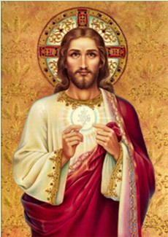
This Sunday, June 4th we have two children receiving Holy Communion for the first time, Peter and Lenka. Please pray for them both as they take this important step, and do your best to be there to encourage and pray for them.

Next week, Thursday, June 8th., is the Feast of Corpus Christi, the Body and Blood of Christ. There will be only one Mass that day, at 9.30am, because we shall also celebrate it on the following Sunday, June 11th. After the 9am Mass on Sunday we shall process down the outside of the church to the garden and, if the weather is good, have Benediction outside on the parish hall steps.

With blessings on every one of our parish family,

Father Francis

ANY OTHER BUSINESS

POLITE NOTICE! If you should use the hall, please leave it as you would wish to find it.
ISOBEL has a few ornaments for sale and there will be a table in the hall after Sunday Mass.
KNIT & NATTER Next meeting in the Hall on Tuesday 6 June (2-4pm). All crafters welcome! Christina

I have been given a Garmin satnav, all new and still in the box. I have one already, and if anyone would like this then you will be most welcome, so just let me know.
Father Francis
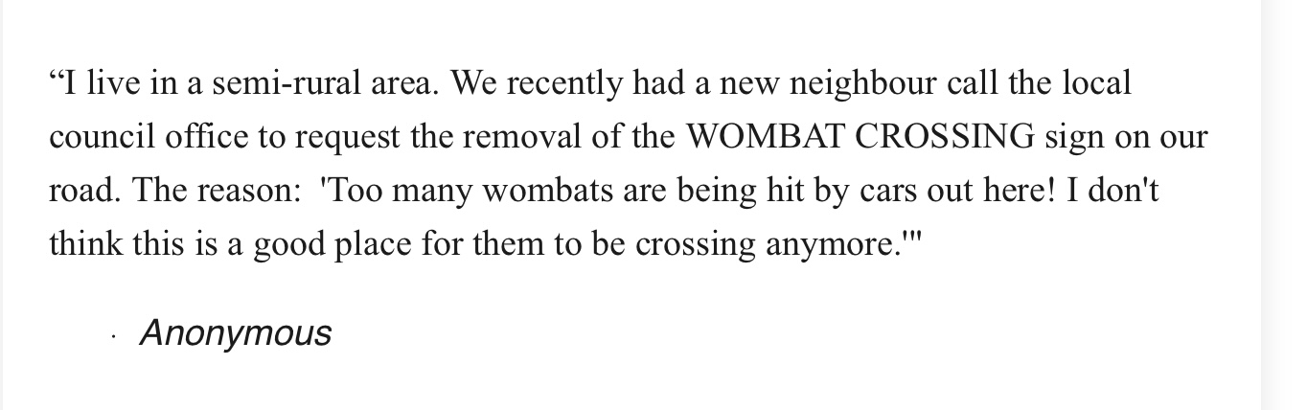
- submitted by Tom and Teresa.

The heart of our good Mother Mary is all love and mercy. She desires nothing else but our happiness. We need only have recourse to her and we will be heard. - St Jean Vianney

