Palm Sunday 2 April 2023 Holy Week/Psalter Week 2
OUR LADY OF LOURDES AND SAINT CECILIA
Parish Administrator: Mgr Francis Jamieson
Landline: 01258 452051 Mobile: 07826 732493
Hospital RC Chaplains:
Dorchester: Fr Barry Hallett 01305 255198; Poole: Deacon Declan McConville 01202 442167 Newsletter: newsletterblandfordcatholics@yahoo.co.uk
Website: blandfordcatholics.org
Plymouth Diocesan Trust Registered Charity No. 213227

Please keep in your prayers: Rose Grant, Ruby Cooper, Iris Bell; Christopher; Noreen Breadmore; Christina and John Morley; Leeah, Marjorie’s daughter; Sandra, Teresa and Tom’s niece; Hilary Gent; Father Tom, and all at the Care Home where he is chaplain; and all families of those suffering at this time.

MASS INFORMATION CORRECT AT TIME OF PUBLISHING BUT MAY BE SUBJECT TO CHANGE AT SHORT NOTICE

HOLY WEEK YEAR A1

Saturday April 1
9.30am Traditional Latin Mass
4.30pm Confessions
5.30pm Vigil Mass of Sunday
Sunday 2 April PALM SUNDAY OF THE PASSION OF THE LORD
8.00am Confessions
9.00am Holy Mass
Monday of Holy Week April 3
8am Confessions
9.10am Morning Prayers 9.30am HOLY MASS followed by STATIONS OF THE CROSS
Tuesday of Holy Week April 4
5pm Confessions
6.10pm Evening Prayers 6.30pm HOLY MASS
Wednesday of Holy Week April 5 CHRISM MASS AT CATHEDRAL
8am Confessions
9.10am Morning Prayers 9.30am HOLY MASS
MAUNDY THURSDAY April 6
7pm Mass of the Last Supper
and Watch at the Altar of Repose
GOOD FRIDAY April 7
10am STATIONS OF THE CROSS
2pm Confessions
3pm Liturgy of Good Friday
HOLY SATURDAY April 8
6.30pm Confessions
8pm Easter Vigil
Sunday April 9 EASTER SUNDAY
9.00am HOLY MASS

THE TIMES OF SERVICE IN HOLY WEEK WILL BE AS FOLLOWS:

Holy Thursday - Mass of the Last Supper and watch at the altar of repose begins at 7pm on Thursday, April 6th.
Good Friday - the Good Friday Liturgy will be at 3pm on Friday, April 7th.
Holy Saturday - the Easter Vigil will begin at 8pm.
Confessions will be heard from 4.30pm on Saturday, April 1st. and from 8am on Palm Sunday morning, April 2nd. Every day from 8am until 9.10am during Holy Week, and from 5.30pm on Holy Thursday; from 2pm on Good Friday; and from 6.30pm on Holy Saturday.

ON THURSDAY, 18 MAY 2023 the Catholic Children’s Society (Plymouth) is holding an Ascension Day fundraiser at Buckfast Abbey.
The event starts at midday with Holy Mass in the Abbey, followed by a 2 course lunch, raffle and then finishing off with a guest speaker. We are delighted to announce that Rear Admiral Chris Snow CBE, the Deputy Lord-Lieutenant of Devon will join us to talk about his role assisting the Lord-Lieutenant of Devon, who is His Majesty the King’s personal representative in the county.
Tickets are available on a first come-first served basis and are priced at £30 with all proceeds going towards helping vulnerable children and families living in our Diocese. Please call the CCSP office 01364 645420 or email vicki.dunstone@prcdtr.org.uk to book your tickets (or you can speak to Father Francis who has a few tickets to sell on behalf of the CCSP).

PILGRIMAGE TO LOURDES - The planned pilgrimage to Lourdes from 7 - 14 September has had to be cancelled due to lack of support. Tangney Tours have now offered us a quote for a 5 Day, 4 Night pilgrimage to Lourdes by Air from 11 - 15 September. The cost is £650 per person** based on a shared room, flying from Heathrow to Toulouse with coach travel onwards to Lourdes. Tangney need to know participation by 14 April as deposits have to paid to British Airways for the flight. There is a list at the back of the church for parishioners to indicate whether they wish to support this amended travel. Ruth **please note: this price does not include travel to Heathrow.

WEEKLY OFFERINGS - £293.87. Thank you to everyone who contributed. FAMILY FAST DAY £405.00 . Ruth

With blessings on every one of our parish family,

Father Francis

THE POPE’S INTENTIONS FOR APRIL
For a culture of peace and non violence
We pray for the spread of peace and non violence, by decreasing the use of weapons by States and citizens.

ANY OTHER BUSINESS
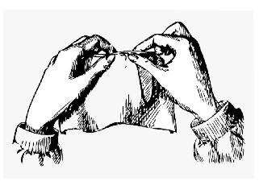
KNIT & NATTER Next meeting in the Hall on Tuesday of Holy Week, 4 April, (2-4pm). All crafters welcome! Christina

LAST LENT LUNCH of 2023, Saturday 12-2pm

DATE | PLACE | HOST(S) | CHARITY
1 April | Hall | Fiona Mackay & Lucy | CAFOD
LENT LUNCHES A huge thank you to everyone who has hosted a lunch, made soup. donated raffle prizes, made cakes or came along and supported the events. They have been a great time to socialise together too. Thanks, Ali and Anna

From Gordon Amery, Steward of Gillingham Methodist Church: On Sunday 7th May 2023, GMC will be hosting a performance of Edward Elgar’s sublime choral work ‘The Dream of Gerontius’ with a 50-strong choir and the international concert organist, David Briggs playing our Sweetland organ and taking the place of an orchestra. Elgar composed this profoundly moving work in 1900 and the score was set to the text of a poem by Cardinal John Newman. It relates the journey of a pious man’s soul from his deathbed to his judgement before God and settling into Purgatory with the promise of everlasting glory.
As you can appreciate, an event of this magnitude does not come cheaply and we have set an admission price of £20. For more information, please see posters in porch.

ST. EDWARD’S WAY—PART TWO Monday 20th March started gloomy but we set out cheerfully and apart from some light showers kept dry. The walk from Winterborne Muston soon crosses the ancient Roman road running from Badbury Rings to Dorchester, and then gently goes uphill to the Combs Ditch, a Bronze Age earthwork which runs along a dramatic ridge with long views to the north and south. Alas, the section we were supposed to walk on had become an impressive bog, thanks to the efforts of horse riders and cyclists, not to mention the weather, so we diverted along a field boundary to reach Charisworth. Here a flock of geese charged towards us honking at full throttle before we continued along the ridge towards Winterborne Stickland, enjoying wonderful views. We finished for the day in the village, looking forward to the next stretch to Child Okeford.
We are walking the Way to raise money for Cafod and would be very grateful for any sponsorship ( of course, we can’t deny this is great fun as well! ). Please either put your money in an envelope marked St. Edward’s Way and put it in the collection, or give the envelope to Ruth or to Madeleine.....but as the financial year is so near its close, it would be helpful if any sponsorship money is put in the collection, or given to us, after 5th April. Further accounts of the route to follow! Madeleine and Ruth

*******************************************************************

When fishes flew and forests walked
And figs grew upon thorn,
Some moment when the moon was blood
Then surely I was born.

With monstrous head and sickening cry
And ears like errant wings,
The devil’s walking parody
On all four-footed things.

The tattered outlaw of the earth,
Of ancient crooked will;
Starve, scourge, deride me: I am dumb,
I keep my secret still.

Fools! For I also had my hour;
One far fierce hour and sweet:
There was a shout about my ears,
And palms before my feet.
G K Chesterton, The Donkey
(contributed by Tom and Theresa)

******************************************************************

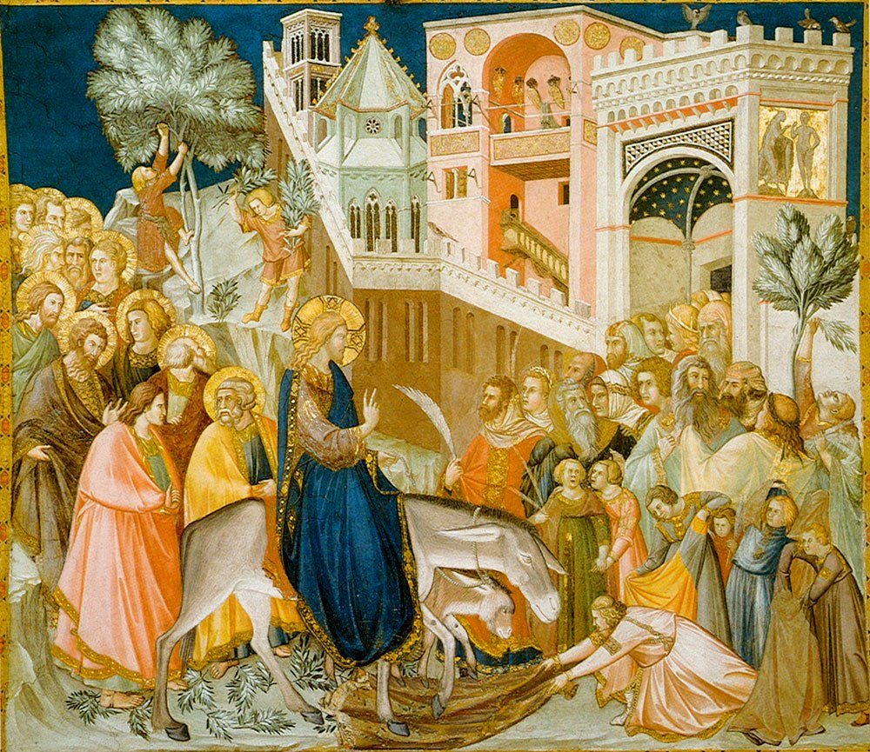
Assisi-frescoes-entry-into-jerusalem-pietro lorenzetti
source: Wikimedia Commons

