**CATHOLIC CHILDREN'S SOCIETY (PLYMOUTH)**

**NEEDS YOU !**



It is with great sadness that the trustees of the Catholic Children's Society (Plymouth) share the news that our Co-Chair, John Larter died suddenly on Friday, 30th December 2022. And so we continue our work with an empty chair at the table. Could you be the person to fill it?

We need enthusiastic trustees who can commit to serving on the board. Your skill set might be just what we need.  We need people with professional skills in areas such as business/finance, HR and social care. This is a voluntary position, both rewarding and challenging.

We are also looking for youth trustees to bring the views of young people to our work. Maybe you are at university or have just completed your studies and think you would enjoy making a difference to some of the most deprived families in our Diocese ?

This volunteering role would give you good business experience, an ability to find out how a small charity works, knowledge of safeguarding, as well valuable experience working as part of a diverse team and much more. You will need to be aged 18+.

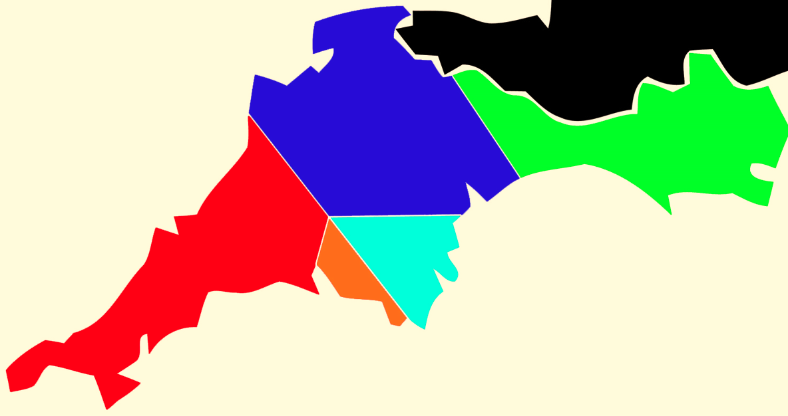

CCSP support families in need across the Plymouth Diocese, which covers Devon, Cornwall and parts of Dorset.

Further details can be found by visiting our website [**www.ccsplymouth.org.uk**](http://www.ccsplymouth.org.uk), by contacting the office on **01364 645420** or by emailing [**ccs@prcdtr.org.uk**](mailto:ccs@prcdtr.org.uk) to make further enquiries about becoming a Trustee Director for CCSP.