Sunday 19 February 2023 Divine Office: Week 2 : Wed-Sat Week 4
OUR LADY OF LOURDES AND SAINT CECILIA
Parish Administrator: Mgr Francis Jamieson
Landline: 01258 452051 Mobile: 07826 732493
Hospital RC Chaplains:
Dorchester: Fr Barry Hallett 01305 255198; Poole: Deacon Declan McConville 01202 442167 Newsletter: newsletterblandfordcatholics@yahoo.co.uk
Website: blandfordcatholics.org
Plymouth Diocesan Trust Registered Charity No. 213227

Please keep in your prayers: Ruby Cooper, Iris Bell; Christopher; Noreen Breadmore; Christina and John Morley; Leeah, Marjorie’s daughter; Sandra, Teresa and Tom’s niece; Father Tom, and all at the Care Home where he is chaplain; and all families of those suffering at this time.

MASS INFORMATION CORRECT AT TIME OF PUBLISHING BUT MAY BE SUBJECT TO CHANGE AT SHORT NOTICE

SEVENTH WEEK IN ORDINARY TIME YEAR A1

Saturday February 18
9.30am LATIN MASS
5.30pm Vigil Mass of Sunday
Sunday February 19 7th SUNDAY IN ORDINARY TIME
- DAY FOR THE UNEMPLOYED
9.00am HOLY MASS
Monday February 20 9.10am Morning Prayers 9.30am HOLY MASS
Tuesday February 21 St Peter Damian, Doctor of the Church (Opt Mem)
6.10pm Evening Prayers 6.30pm HOLY MASS
Wednesday February 22 ASH WEDNESDAY
9.10am Morning Prayers 9.30am HOLY MASS and 6.30 pm
Thursday February 23 St Polycarp (Comm) 9.10am Morning Prayers 9.30am HOLY MASS
Friday February 24 9.10am Morning Prayers 9.30am HOLY MASS followed by Benediction
Saturday February 25
9.30am LATIN MASS
5.30pm Vigil Mass of Sunday
Sunday February 26 FIRST SUNDAY OF LENT
9.00am HOLY MASS

1. Lent is early this year, and next Wednesday, February 22nd., is Ash Wednesday. There will be Mass and imposition of the ashes at 9.30am and 6.30pm.
2. During Lent there will be a course on the Mass each Tuesday for half an hour after the 6.30pm Mass, i.e. from 7 - 7.30pm, and on Wednesday afternoons from 2-2.30pm.

This year Fr. Pat O’Beirne, a priest from the Missionary Society of St. Columban, will come to preach an appeal on Saturday and Sunday, the 25th. & 26th. February. It is the only missionary appeal we have, so please be good enough to remember to bring as generous an offering as you can afford for the work of the Columban missionaries. They publish the magazine put out in church called “The Far East”, which is always interesting and helps us to see the work they are doing.
They work in Australia, Chile, China & Hong Kong, Fiji, Ireland, Japan, Korea, and Myanmar.
The Missionary Society of St. Columban is an international Catholic missionary society that crosses boundaries of culture and religion. In the countries where they work Columban Missionaries - priests, sisters, and lay missionaries - live and share the Gospel of Jesus Christ through working with poor and exploited peoples.
Please try to do your best to help. Their vocation is to preach the Gospel in the broadest sense: to be one with Jesus Christ in helping people who are often exploited to be full and happy human beings with a sense of the goodness of God.
WEEKLY OFFERINGS To be published when available. STANDING ORDERS - Amounts for December - Gift Aided £1,762.50, Non Gift Aided £190.00. Amounts for January - Gift Aided £1,162.50, Non Gift Aided £315.00.Thank you to everyone who contributed. Ruth
With blessings on every one of our parish family,

Father Francis
ANY OTHER BUSINESS

LENT LUNCHES These will begin with a lunch on Saturday, 25th February, 12-2pm in the church hall to raise money for CAFOD, hosted by Anna and Ali. There is a sign up sheet at the back of the church for anyone else who wants to volunteer to host one, either for CAFOD or another charity. This can be in your own home or the church hall. Each Saturday in Lent we will have a chance to share a simple meal of bread and soup together, raising money for people in need of our help. Ali and Anna
KNIT & NATTER next meeting in the hall, Tuesday February 21. All crafters welcome! Christina
THE PARISH SWEEPSTAKE took £490, of which half is being returned in prizes. At the Parish Lunch the first three prizes were drawn: 1st prize of £100, Jan Smith; 2nd prize (£50), Marie & Barry Vardill; and 3rd prize, free entry into next year’s draw, Fr Francis. The remaining prize money will be drawn later in the year. Thank you to everybody for taking part. Mike Moore
This is advance notice of the CAFOD BIG LENT WALK. Throughout Lent CAFOD is challenging us to to walk 200km to raise money for CAFOD's vital work in helping the most disadvantaged families. We have a parish fundraising page and perhaps collectively we can walk 200km. https://cafod.enthuse.com/pf/lourdes-st-cecilia. If you can get family or friends to sponsor you, please use this page. You could choose to do any sized walk throughout Lent on any day of your choosing. Let me know what distance you have walked and I'll update our fundraising page. Or join us on Saturday 25th March when many of the parishes in Dorset are planning to walk together. We are hoping to walk on the trailway and meet up with Shaftesbury and Marnhull parishioners, maybe at the Shillingstone railway station. This will then be followed by a Lent lunch at Charlie's house in Shillingstone for those who want to combine the 2 events. More details of this walk will follow but keep the day free if you can. Ali & Anna

ARTSREACH brings 2 exciting shows to Blandford this season. We present the fabulous Balbir Singh Dance Company and

Dorset’s Ridgeway Singers and Band … (for details see posters in porch). Love and Spice Balbir Singh Dance Company 7.30pm Friday 24th February Blandford Corn Exchange Tickets £10, £5 (u18), Family £25, from www.artsreach.co.uk

St Cecilia Parish Lunch on 11 February 2023
at The Old Powerhouse

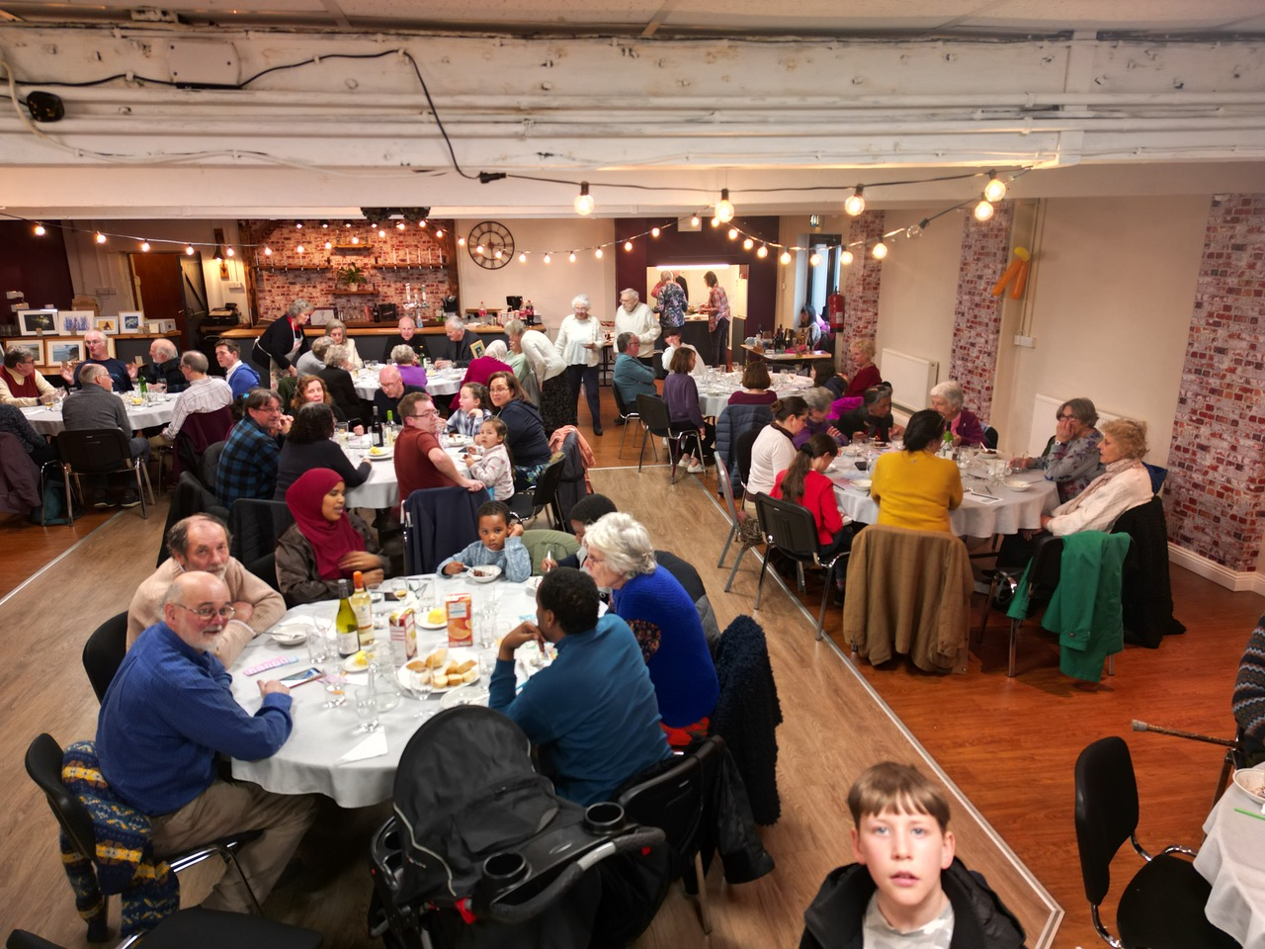

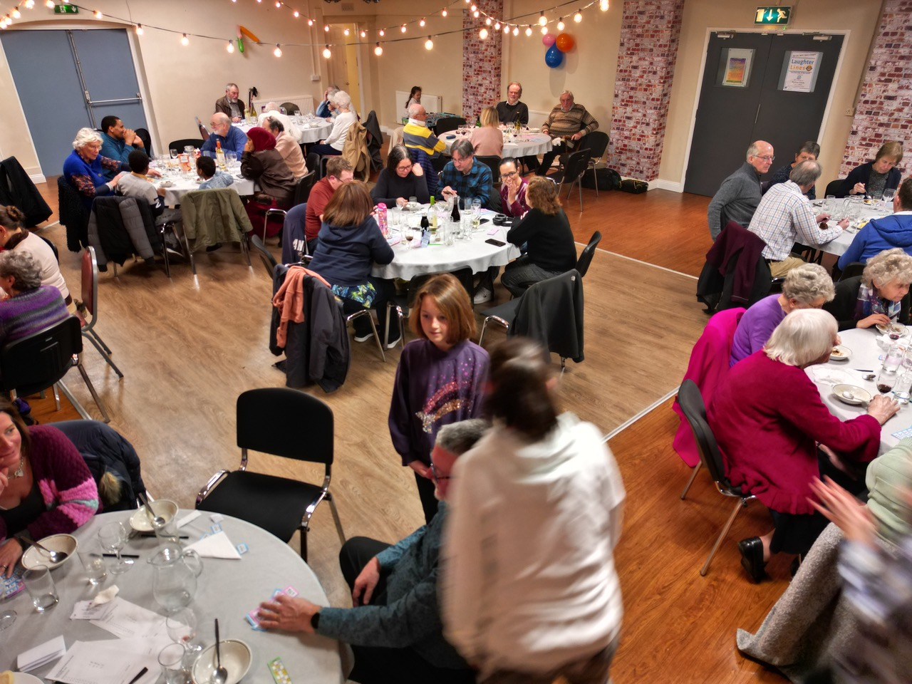
If anyone would like copies of the photos taken at the parish lunch please speak to Adrian Fisher. The images are “large”, about 200 KB each in size. They can be provided at higher resolutions if required, up to 6 MB per photo.

