Sunday 5 February 2023 Divine Office: Week 1
OUR LADY OF LOURDES AND SAINT CECILIA

Parish Administrator: Mgr Francis Jamieson
Landline: 01258 452051 Mobile: 07826 732493
Hospital RC Chaplains:
Dorchester: Fr Barry Hallett 01305 255198; Poole: Deacon Declan McConville 01202 442167 Newsletter: newsletterblandfordcatholics@yahoo.co.uk
Website: blandfordcatholics.org
Plymouth Diocesan Trust Registered Charity No. 213227

Please keep in your prayers: Ruby Cooper, Iris Bell; Christopher; Noreen Breadmore; Christina and John Morley; Leeah, Marjorie’s daughter; Sandra, Teresa and Tom’s niece; Father Tom, and all at the Care Home where he is chaplain; and all families of those suffering at this time.

MASS INFORMATION CORRECT AT TIME OF PUBLISHING BUT MAY BE SUBJECT TO CHANGE AT SHORT NOTICE

FIFTH WEEK IN ORDINARY TIME YEAR A1

Saturday February 4 : 9.30am LATIN MASS
5.30pm Vigil Mass of Sunday
Sunday February 5 9.00am HOLY MASS - RACIAL JUSTICE DAY - JUSTICE AND PEACE IN THE WORLD
Monday February 6 : St Paul Miki and Companions, Martyrs (Mem)
9.10am Morning Prayers 9.30am HOLY MASS
Tuesday February 7 : 6.10pm Evening Prayers 6.30pm HOLY MASS
Wednesday February 8 DAY FOR VICTIMS OF TRAFFICKING
St Jerome Emiliani Patron of Orphans and St Josephine Bakhita (Opt Mems)
9.10am Morning Prayers 9.30am HOLY MASS
Thursday February 9 St Teilo
9.10am Morning Prayers 9.30am HOLY MASS
Friday February 10 St Scholastica Patron of convulsive children (Mem)
9.10am Morning Prayers 9.30am HOLY MASS followed by Benediction
Saturday February 11 : OUR LADY OF LOURDES, PATRONAL FEAST
THE SICK AND THOSE WHO CARE FOR THEM - WORLD DAY FOR THE SICK
9.30am LATIN MASS
5.30pm Vigil Mass of Sunday
Sunday February 12 6th SUNDAY IN ORDINARY TIME
9.00am HOLY MASS

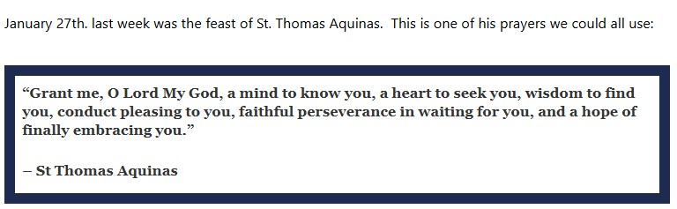

LEANDER CUNNINGHAM, who lived in the parish and has attended several events, including our pilgrimage to Walsingham, died unexpectedly yesterday, February 1st. Please pray for her soul.

OUR LADY OF LOURDES FEAST DAY - 11 FEBRUARY - PARISH LUNCH - 12 noon for 12.30 pm Please keep this date free and come and help us celebrate our Patronal Feast Day. It will be in the Powerhouse at Bryanston (Marie has kindly sent the map below). This is the last weekend to buy tickets after Mass and for donating raffle prizes. Thank you for all contributions.

WEEKLY OFFERINGS £220.79.
EVC UGANDA APEAL - ‘Boniface’ has been counted and £404.91 has been sent to assist Jackline Namatoya with her education. Thank you to everyone who contributed. Ruth
With blesgs on every one of our parish family,

Father Francis

CAR PARKING PLEASE NOTE - THERE WILL BE LIMITED PARKING

In no other spot as much as Lourdes do we feel so impelled toward prayer, forgetfulness of self, and charity. The most fervent are attracted to a life more totally offered to God's service. The less fervent become aware of their tepidity and rediscover the way of prayer. Hardened sinners and unbelievers are often touched by grace. - Pope Pius XII

ANY OTHER BUSINESS

KNIT & NATTER next meeting in the hall, February 7th. All crafters welcome! Christina

ST RITA’S SHOP in Honiton is offering Lent/Easter religious articles, and we hope your parishioners might find this range inspiring. I think you will find St. Rita’s shop prices very competitive. You can find our shop online at www.stritascentre.shop with many more items for sale, such as books, statues, holy pictures, etc. Orders can be made online www.stritascentre.shop, by email: shop@stritascentre.org or by phone 01404 42635.

CARITAS Diocese of Plymouth’s January newsletter is at:https://tinyurl.com/2jd785ws

OUR SPRING COMMUNITY EXPO Father Francis has received the following message from the Mayor’s Office:-
“Our Spring Community Expo is taking place, 10am – 1pm, at the Corn Exchange on Saturday 25th March 2023. This is a great opportunity for people in the local community to find out what local groups have to offer. At the moment we are compiling a list of those groups/organisations who are interested in having a table at the event.”
Please contact Father Francis if you are interested.

RAFFLE FOR THE PARISH LUNCH on 11th February All donations to the raffle gratefully received! Last weekend to donate is this weekend. Please put items in the box at the back of church or give to them to Madeleine....and it would be very kind if you would do a quick check on any expiry dates!! Thank you! Madeleine

