16 January 2022 Divine Office: Week 2
OUR LADY OF LOURDES AND ST CECILIA

Parish Administrator: Mgr. Francis Jamieson
Landline: 01258 452051 Mobile: 07826 732493
Hospital RC Chaplains:
Dorchester: Fr. Barry Hallett 01305 255198, Poole: Deacon Declan McConville 01202 442167
Newsletter: newsletterblandfordcatholics@yahoo.co.uk
website: blandfordcatholics.org

Please keep in your prayers:
Keith Wareham; Leander; Father Tom and all at the Care Home where he is Chaplain;
and all families of those suffering at this time.

MASS INFORMATION CORRECT AT THE TIME OF PUBLISHING BUT MAY BE SUBJECT TO CHANGE AT SHORT NOTICE
SECOND SUNDAY IN ORDINARY TIME - YEAR C
Saturday January 15
9.30am (EF) HOLY MASS
5.30pm HOLY MASS OF SUNDAY : THE SECOND SUNDAY OF THE YEAR
Sunday January 16
9am HOLY MASS
Monday January 17 9.30am HOLY MASS St Anthony the Great of Egypt (Mem)
Tuesday January 18 6.30pm HOLY MASS
(Octave of prayer for Christian Unity until 25th)
Wednesday January 19 9.30am HOLY MASS St Wulfstan, Bishop (Opt Mem)
Thursday January 20 9.30am HOLY MASS St Fabian, Pope, and St Sebastian, Martyrs (Opt Mems)
Friday January 21 9.30am HOLY MASS St Agnes (Mem) Patron of betrothed couples, gardeners and young girls
followed by Benediction
Saturday January 22
St Vincent, Deacon, Martyr (Opt Mem)
9.30am (EF) HOLY MASS
5.30pm HOLY MASS OF SUNDAY : THE THIRD SUNDAY OF THE YEAR
Sunday January 23
9am HOLY MASS

We shall keep enhanced hygiene, cleaning, and safety measures in place.

IT IS NOW MANDATORY TO WEAR MASKS IN CHURCH.

VATICAN NEWSLETTER If anyone would like to see the Vatican News regularly, it is free, and you can subscribe here: https://www.vaticannews.va/en/newsletter-registration.html or just type “subscribe Vatican newsletter” into your search engine.

PRAYERS FOR THE CHURCH At another, previous difficult time in the history of Christianity Pope Leo XIII instituted prayers to be said at the end of Mass. They are usually called the Leonine Prayers, asking God and Our Lady, the first Christian, to look after us. They are brief, express faith and trust in God while fully recognising the dangers that surround us and trust in God. I think that it would be good to have them at the end of Mass on week-days. They finish with Most Sacred Heart of Jesus - have mercy on us. There are worse ways of raising our hearts and thoughts to God as we leave church.
SYNOD I know we have all been busy over the past month, but it would be good to have some of your remarks for the Synod. There are still some forms at the back of church if you could possibly take one and respond with your ideas - only 4 questions.
FROM THE RIGHT TO LIFE Now that we have shown the abortion lobby that together we can effectively stop them ending more lives through extreme changes to abortion legislation, we are to move onto the next stage of the plan - moving from defensive wins, to passing pro-life ready legislation that will save many more lives.
WEEKLY OFFERINGS £184.60. Thanks to all who contributed. CATHOLIC CHILDREN’S SOCIETY (CRIB) £485.45. Mike

With blessings on every one of our parish family.

Father Francis

ANY OTHER BUSINESS

We plan to have our PARISH MEAL together next month on the day after the feast of Our Lady of Lourdes, a very suitable way of celebrating Our Lady’s patronage of our parish. That is, SATURDAY, FEBRUARY 12th., at 12.30.
We shall know exactly where in a day or two.
For the sake of our parish community, please do try to come. Father Francis

UNCOLLECTED CHRISTMAS CARDS Do have a look and see if there are any cards for you at the back of church. At least one, I know, is for someone who has drawn a lucky number in the parish sweepstake, but there are many others and perhaps the sender might be hurt if you don’t even have a look and it has to be cleared away. Fr Francis

The decorated Christmas Tree entered for the Blandford Town Christmas Tree Competition was selected as the Mayors Choice, and in due time we will receive a Trophy. Julie

We have received the followig letter from Claire Stokoe, our Mayor’s secretary. Would anyone like us to take part in this, or have any ideas for us. I can find out more about what they expect. Unfortunately I cannot be there. Fr Francis
"We are planning our next Community Expo in the Corn Exchange for Saturday 26th If you would like to attend this Expo, please let me know by responding to this email.
More details will be sent at a later date once we have an idea of what restrictions, if any could be in place."

The Diocese are running an online event on 8 February about refugees and migrants which will also have a focus on community sponsorship and someone will be sharing the experience of Sidmouth parish which is the first to welcome a refugee family. Should you wish to join, the link is https://www.plymouth-diocese.org.uk/welcome-the-stranger/
The time of the event will be advised beforehand. Anthony
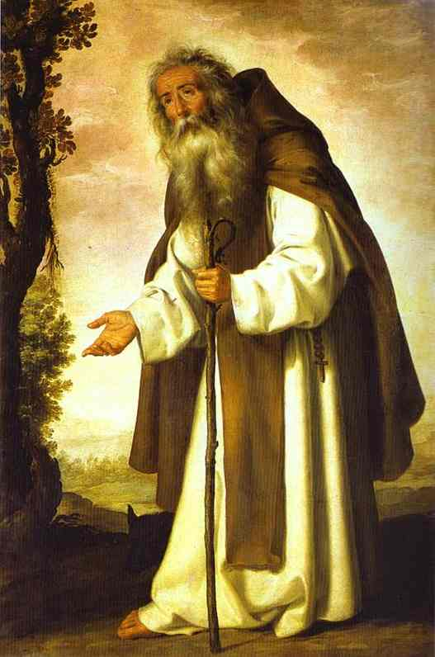
St Anthony of Egypt (251-356) At 20, St Anthony had inherited his parents' estate near Memphis, Egypt. One Sunday at Mass, the Gospel spoke directly to the wealthy young man: "If you wish to be perfect, go and sell your possessions and give the money to the poor, and you will have treasure in heaven; then come, follow me." (Mt 19:21) The youth took Christ's words literally. He disposed of everything and moved to a hut outside of town. He stayed there 15 years, practicing the asceticism he learned from hermits who lived nearby. Then, because he desired uninterrupted solitude, he withdrew to an isolated mountain in the Egyptian desert.
Anthony followed the same pattern every day. He ate only a little bread and water after sunset. He wore sheepskin garments with the hair against his body and never bathed. He supported himself by weaving mats from palm fronds. And Anthony prayed constantly. He especially liked to pray at night, complaining that the morning sun robbed him of the greater inner light of contemplation.
St Athanasius, Anthony’s biographer, say that the devil opposed the saint all through his life. Thus, he became adept at spiritual warfare. ....
Anthony’s reputation for holinss and spiritual power spread throughout Egypt. Many people interrupted his solitude to ask him for prayer, advice, and healing. At age 55 Anthony entered a more active phase in his spiritual career. He founded a community of monks who lived as hermits, but came together for worship and teaching. He had always maintained contact with the church at Alexandria. But now at the request of St Anthanasius, the patriarch and his friend, he visited the city to support Christians during persecutions and to wield his immense influence against heretics. St Anthony died in 356 at the age of 105 years old.

We welcome contributions to this newsletter from parishioners; please send in links to websites, hard copy, email pictures, prose or poetry, whether to inform or to entertain....

ST. AGNES’ Eve—Ah, bitter chill it was!
The owl, for all his feathers, was a-cold;
The hare limp’d trembling through the frozen grass,
And silent was the flock in woolly fold:
Numb were the Beadsman’s fingers, while he told 5
His rosary, and while his frosted breath,
Like pious incense from a censer old,
Seem’d taking flight for heaven, without a death,
Past the sweet Virgin’s picture, while his prayer he saith.

His prayer he saith, this patient, holy man; 10
Then takes his lamp, and riseth from his knees,
And back returneth, meagre, barefoot, wan,
Along the chapel aisle by slow degrees:
The sculptur’d dead, on each side, seem to freeze,
Emprison’d in black, purgatorial rails: 15
Knights, ladies, praying in dumb orat’ries,
He passeth, his weak spirit fails
To think how they may ache in icy hoods and mails.
- John Keats, from The Eve of St Agnes
(contributed by Avis)

***************************************

"If your case be brought to the last extremity and that you are at the pit's brink, even the very margin of the grave, yet then despair not. At least put it off a little longer, and remember that whatsoever final accident takes away all hope from you, if you stay a little longer and in the meanwhile bear it sweetly, it will also take all despair too. For when you enter the regions of death, you feel rest from all your labours and your fears."
- Jeremy Taylor, Holy Living and Holy Dying
(contributed by Avis)

**********************************************

Go to Mary, then. Praise her, and you will be enlightened. For it is through her that the true Light shines on the sea of this world. – St Ildephonsus
(contributed by Hilary)

