10 October 2021 Divine Office: Week 4
OUR LADY OF LOURDES AND ST CECILIA

Parish Administrator: Mgr. Francis Jamieson
Landline: 01258 452051 Mobile: 07826 732493
Hospital RC Chaplains:
Dorchester: Fr. Barry Hallett 01305 255198, Poole: Deacon Declan McConville 01202 442167
Newsletter: newsletterblandfordcatholics@yahoo.co.uk
website:: blandfordcatholics.org

27th WEEK IN ORDINARY TIME YEAR B1
Please keep in your prayers:
Keith Wareham; Brendan Hewson; Seth Cartwright who is slowly recovering;
Father Tom and all at the Care Home where he is Chaplain;
and all families of those suffering at this time.

MASS INFORMATION CORRECT AT THE TIME OF PUBLISHING BUT MAY BE SUBJECT TO CHANGE AT SHORT NOTICE

Saturday October 9
St Denis and Companions (Opt Mem) Patron of France
St John Leonardi (Opt Mem)
St John Henry Newman (Opt Mem)
HOLY MASS 9.30am (EF)
5.30pm HOLY MASS of Sunday
Sunday October 10 9am HOLY MASS - PRISONS WEEK (until 16th) PRAYER FOR PRISONERS AND THEIR FAMILIES
Monday 9.30 am October 11 HOLY MASS St John XXIII (Opt Mem)
Tuesday 6.30pm October 12 HOLY MASS St Wilfrid (Opt Mem)
Wednesday 9.30am October 13 HOLY MASS St Edward the Confessor (Opt Mem)
Patron of kings, difficult marriages and separated spouses
Thursday 9.30pm October 14 HOLY MASS St Callistus I (Opt Mem)
Friday 9.30am October 15 HOLY MASS St Teresa of Jesus, Doctor of the Church (Mem) Patron of lace-makers and headache sufferers
followed by Benediction
Saturday 9.30am October 16
St Hedwig, St Margaret Mary Alacoque (Opt Mems); St Richard Gwyn
HOLY MASS 9.30am (EF)
5.30pm HOLY MASS of Sunday
Sunday October 10 9am HOLY MASS

There will be a second collection this Sunday for the work of PACT (Prison Advice & Care Trust).

PLEASE PRAY FOR the repose of the soul of David Hyde and for Frances and all their family.

We shall keep enhanced hygiene, cleaning, and safety measures in place, so, as before, you will find sanitiser instead of Holy Water, and “Track and Trace” forms at the church entrance. WE SHOULD CONTINUE TO WEAR MASKS IN CHURCH.

(Please put your envelopes with the CAFOD Fast Day collection in the bucket)

JOIN BISHOP MARK O’TOOLE AND THE LATIN MASS SOCIETY on pilgrimage in the beautiful church of Our Lady Queen of Martyrs & St. Ignatius, North Road, Chideock, Dorset, on Saturday morning 16th October at 11.30am for Holy Mass in the Traditional Rite in honour of the Chideock Martyrs. The Mass will be followed by Veneration of the Relics. Bring a packed lunch (tea/coffee provided), tour the church, view the stunning sacristy and the ‘Secret Mass Loft’ where Mass was celebrated in penal times, spend time in the church’s museum, listen to a talk on the martyrs and on this unique and beautiful historic church. A real Autumn treat for the whole family which will be filmed for an episode of ‘Christendom Rising.’ For more details email Maurice Quinn on devon@lms.org.uk or phone 07555536579. Car parking.
DUE TO UNFORESEEN CIRCUMSTANCES the pilgrimage to Lulworth Castle has had to be postponed for the foreseeable future. Please look out for a new date in the Spring.
DAVID HYDE’S FUNERAL will take place on Thursday, October 21st. The Requiem Mass will be celebrated at 11am, after which we’ll take David to the cemetery. Some refreshments will be served in the hall at about 1 o’clock. Please pray for the repose of his soul, and also, of course, for Frances and their family. There will be no 9.30 Mass on that day.
OCTOBER 24TH. IS WORLD MISSION SUNDAY, and there will be a collection the entire Church makes every year to support mission.
The need to stand alongside our missionaries in prayer and solidarity has never been so urgent and necessary. In many areas of the world, they will be the first to respond to the physical and spiritual needs of our sisters and brothers who are suffering. And every single donation from these worldwide Masses goes to support churches, hospitals, schools and vocations in countries where the Church is new, young or poor.
This is our chance to show love and solidarity to our global Church family. Through our prayers, we support missionaries everywhere in spreading the Good News. And by donating we respond to Christ’s call to feed the hungry and clothe the naked.
Missio is the Pope’s chosen charity for mission. Missio works with local bishops, churches and missionary congregations, to distribute resources and funds fairly on the basis of need. And all of your donations go directly from England and Wales to the bishops in the mission territories: local church directly helping local church!
Thank you for helping us support churches, hospitals, schools and vocations around the world.
PARISH MEETING As I spoke about at Masses last Saturday and Sunday, now that - one hopes - we can begin to get back to normal, I think it would be a very good idea to have a meeting in church of the whole parish. I can only ask everyone to attend. It is not intended that it should be a long meeting, but I need your guidance and opinions about a few things that require practical decisions.
I can only therefore beg you to come. I would like the meeting to be straight after Sunday Mass on Sunday, October 31st. I am sure that will not be convenient for everyone, but then no date and time ever will be, but although Saturday evening people were not there, most of those present on Sunday morning thought that would be a good time. For the good of the parish I can only beg you to be present. Please do try.
I will put a sheet of paper at the back of church for any suggestions or concerns people have to be discussed at the meeting.
NOVEMBER DEAD LIST November 2nd., All Souls Day, will soon be here. Envelopes will be put out at the back of church this week for anyone who wants to have the departed from your families and friends remembered at the daily Mass during November. November 2nd. falls on a Tuesday this year, and we shall visit the cemetery to bless our graves on that morning.
While on the subject, no Catholic should take part in the rubbishy - one might almost say illiterate - festivities of “Hallowe’en” that the British have copied from the USA. Prayers are needed for the dead, not boring and embarrassing jokes.
CATHOLIC DIARIES 2022 - This is the last opportunity to order a Catholic Diary for 2022. Please put your name, colour choice (not guaranteed) on the list at the back of the church. The cost will be approx. £4.95 plus a small amount for postage. I have been unable to contact Buckfast Abbey to confirm they have pocket diaries in stock but have found another company who produce a diary with a week to 2 pages, so you can see a whole week at a glance. The order will be made this week. Ruth
PILGRIMAGE TO ST CANDIDA’S SHRINE - This is the last opportunity to order photos that were taken on the pilgrimage and they are at the back of the church. If you would like a copy please place your name on the list at the back of the church. I will arrange for copies. The cost will depend on how many are printed. (approx £1 - £1.50). The order will be made this week. Ruth
CAFOD FAMILY FAST - The collection will be forwarded to CAFOD this week so please ensure that your envelope is included in this week’s collection. If you wish to contribute to the Appeal you can use the envelope at the back of the church and use the FREEPOST to post to CAFOD. It is suggested that you send a cheque rather than put cash in the envelope if you are giving by this method.
WEEKLY OFFERINGS £206.00. STANDING ORDERS - Amounts for September - Gift Aided £1,612.50, Non Gift Aided £100.00. Thanks to all who contributed. Ruth

With blessings on every one of our parish family.

Father Francis

THE MAIN ONLINE CHURCHES WE USE ARE:
St. Bede's, Basingstoke www.stbedesbasingstoke.org.uk
St. Mary of all Angels, Worthing https://www.stmaryoftheangels.org.uk/
Our Lady, Star of the Sea, Weymouth. https://www.ourlady-starofthesea.com/
Also: www.churchservices.tv This website gives the times of all Church Services (Mass, Exposition, Holy Hour etc.) at many churches in UK and Ireland from 5.30am until 9.15pm. Tom and Teresa
The following links are also to churches and chapels who are currently streaming live Masses and other services:
LIVE ADORATION FROM TYBURN CONVENT: https://adoration.tyburnconvent.org.uk
There is a webcam in the GROTTO IN LOURDES (just google the words webcam, Lourdes and grotto) and Masses, the recitation of the Rosary and other prayers can be seen there throughout the day. There is a list on their website giving the details of which languages are used at which times. WESTMINSTER CATHEDRAL is now streaming live some Masses and services - please visit the Cathedral's website for further information and future schedules.
www.cpg.church takes you to GUILDFORD PARISH CHURCH website, where there are links to live-streamed Masses and other devotions online (thanks to Ann, Michael and Lynette for this)
BUCKFAST ABBEY The Abbey (now reopened with some restrictions) is livestreaming Mass. You can view these services on YouTube and Facebook.
And here is a link useful to those who are Deaf or hearing-impaired:
SIGNED MASS The parish of Our Lady and St Vincent in Potters Bar, Hertfordshire, is providing a Sign Interpreted Mass for its Sunday Vigil – 6pm every Saturday. You can watch here.
ANY OTHER BUSINESS

RIDE ’N STRIDE A big thank you to everyone who helped to provide refreshments and a welcome at church for the Ride ’n Stride visitors. This is an extract from a letter we received:
“The riders were very enthusiastic about both the very warm welcome and the refreshments at the church of Our Lady of Lourdes & St. Cecilia in Blandford. They did carry on riding, but said they could have stayed the day to eat the cake! It was the best hospitality on their route; a tremendous effort from the church.”
Thank you, everyone! Father Francis

We welcome contributions to this newsletter from parishioners; please send in links to websites, hard copy, email pictures, prose or poetry, whether to inform or to entertain....

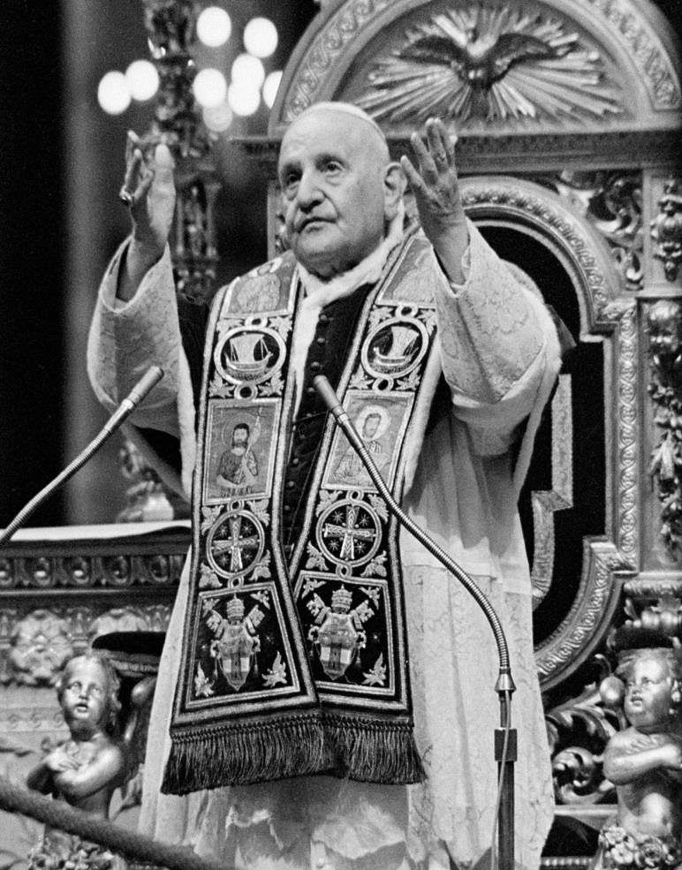

“To keep me from sin and straying from Him, God has used devotion to the Sacred Heart of Jesus in the Blessed Sacrament. My life vows destined to be spent in the light irradiating from the tabernacle, and it is to the Heart of Jesus that I dare go for the solution of all my problems”
-- Pope St John XXIII
(contributed by Hilary)

"May today there be peace within. May you trust God that you are exactly where you are meant to be. May you not forget the infinite possibilities that are born of faith. May you use those gifts that you have received, and pass on the love that has been given to you. May you be content knowing you are a child of God. Let this presence settle into your bones, and allow your soul the freedom to sing, dance, praise and love. It is there for each and every one of us."
- St Teresa of Jesus (of Avila)
(contributed by Hilary)

"Keep your heart in peace and let nothing trouble you, not even your faults."
- St Margaret Mary
(contributed by Hilary)

"Happy are those who recite the Holy Rosary with understanding. They will learn all that is of faith, light, hope, and love in it."
- St Clement Hofbauer
(contributed by Hilary)

"The superfluity of princes is the poverty of the people.....Some are burdened with a mass of clothing, others perish with cold; some, like the rich man who was clothed in purple, have abundance of delicacies and feasts, and Lazarus before the gate dies of hunger....the satiety of the rich is the hunger of the poor man."
- St Alcuin, in a letter to King Ethelred of Northumbria and his nobles
(contributed by Avis)

