19 September 2021 Divine Office: Week 1
OUR LADY OF LOURDES AND ST CECILIA

Parish Administrator: Mgr. Francis Jamieson
Landline: 01258 452051 Mobile: 07826 732493
Hospital RC Chaplains:
Dorchester: Fr. Barry Hallett 01305 255198, Poole: Deacon Declan McConville 01202 442167
Newsletter: newsletterblandfordcatholics@yahoo.co.uk
website:: blandfordcatholics.org

25th WEEK IN ORDINARY TIME YEAR B1
Please keep in your prayers:
Keith Wareham; Brendan Hewson; Seth Cartwright;
Father Tom and all at the Care Home where he is Chaplain;
and all families of those suffering at this time.

MASS INFORMATION CORRECT AT THE TIME OF PUBLISHING BUT MAY BE SUBJECT TO CHANGE AT SHORT NOTICE

Saturday September 18
NO HOLY MASS in the morning (EF)
5.30pm HOLY MASS of Sunday
Sunday September 19
9am ONLY HOLY MASS HOME MISSION DAY - THE SPREAD OF THE GOSPEL
Monday September 20 9.30am HOLY MASS Ss Andrew Kim Tae-gŏn, Priest, Paul Chŏng Ha-sang, and Companions, Martyrs (Mem)
Tuesday September 21 6.30pm HOLY MASS ST MATTHEW APOSTLE, EVANGELIST (FEAST)
Wednesday September 22 9.30am HOLY MASS DEDICATION OF THE CATHEDRAL (1880), (FEAST)
Thursday September 23 9.30am HOLY MASS St Pio of Pietrelcina (Padre Pio) (Mem)
Friday September 24 9.30am HOLY MASS Our Lady of Walsingham (Mem)
followed by Benediction
Saturday September 25
HOLY MASS 9.30am (EF)
5.30pm HOLY MASS of Sunday
Sunday September 26
9am ONLY HOLY MASS - THE HARVEST; THE FRUITS OF HUMAN WORK, AND THE REVERENT USE OF CREATION

There will be a mandatory Retiring Collection for Home Mission Day

The Latin Mass Society traditional Latin Mass will be celebrated in church at 12 noon on the feast of the archangels SS. Michael, Gabriel, and Raphael on Wednesday, September 29th.

We shall keep enhanced hygiene, cleaning, and safety measures in place, so, as before, you will find sanitiser instead of Holy Water, and “Track and Trace” forms at the church entrance. WE SHOULD CONTINUE TO WEAR MASKS IN CHURCH and, although singing is now allowed, it might be best to restrict it to the Alleluia, which should always be sung anyway.

Please say a prayer of thanksgiving for Brendan Hewson who is recovering from a successful operation.
We should see about reading in church. Would anyone like to read? Please think before saying no! It is important for the Word of God to be read as well as we can manage, and some training will be given, as well as practical tips.
This really is very important, so please do not immediately think it is beyond you or you won’t be good enough. Training is given, and if you do not wish to proceed that will be fine. If we do not have enough readers, the consequence will be that the priest will read everything, so be warned!
There will be a paper at the back of church to put your name and email or telephone number, and I can only beg you to take this seriously.
One reason why the Vatican is important to diplomats. The Vatican’s networks are phenomenal, stresses the new British Ambassador to the Holy See, Christopher John Trott. “No government has sub-offices in every parish in every country, which the Vatican does”, and that makes for “a really advantageous relationship for us because, as a government we can provide funding to organisations to do their work on the ground, but we can't reach down into local communities.”
WARDOUR CASTLE In 1778 the Papists Act allowed Catholics in this country some of the first freedoms permitted since the Protestant Reformation. It did not allow us to worship, but we were permitted to be in the army and to inherit property. In 1791 we were allowed to have schools, to hold some very junior public offices, and to live in London. Another Act was passed in 1793 to allow us to take degrees but not to have full standing in the universities (that did not come until 1873).
To some great families - the Welds in Dorset, for example - the Catholic Church in this kingdom owes an enormous debt because they were able to practise the faith secretly, smuggling in priests to celebrate Mass for themselves and for their tenants who remained faithful. In 1829 we were at last given freedom to worship and therefore to build churches, as long as we were careful. Our church in Marnhull, for example, was built in 1832, hidden deep in the country. If a Catholic house had a chapel before 1829, it could not be visible from the outside because we were not allowed to construct a church as a separate building. An example of this is at Wardour Castle, just the other side of Shaftesbury.
When the Arundell family, Catholics, built the new house, the chapel was incorporated into the house. From the outside, therefore, there is no indication of its existence. Wardour Chapel is beautifully decorated and was opened by Bishop Walmesley, the Vicar Apostolic of the Western District, on November 1st, 1776, with ecclesiastical ceremonial not seen by Catholics in England since the Reformation.
Today the parish of Tisbury provides a priest to celebrate Mass in Wardour Castle chapel. Fr. Miller has given permission to Fr. Francis to celebrate Mass there on Tuesday, September 28th. The chapel is very beautiful and if anyone would like to come as part of a group you are most welcome. After Mass we shall be shown some of the lovely vestments and other things the family has accumulated over several hundred years of faithful adherence to the faith that made England Christian.
A paper will be put at the back of the church for you to sign if you would like to come. Please do. It takes 30-45 minutes to get there from Blandford and we can probably organise a minibus if there are enough who would like to go. If there are not enough, we can organise it in cars. It is a good opportunity for anyone who is interested in the local history of our faith. CATHOLIC DIARIES 2022 - If you wish to order a Catholic Diary for 2022, please put your name and colour choice (not guaranteed) on the list at the back of the church. The cost will be approx. £4.95 plus a small amount for postage. I have been unable to contact Buckfast Abbey to confirm they have pocket diaries in stock but have found another company who produce a diary with a week to 2 pages, so you can see a whole week at a glance. I intend to place the order in the week beginning 11 October. Ruth Hiscock

PILGRIMAGE TO ST CANDIDA’S SHRINE - There are 2 photos that were taken on the pilgrimage and they are at the back of the church. If you would like a copy please place your name on the list at the back of the church. I will arrange for copies. The cost will depend on how many are printed. (approx £1 - £1.50). I will arrange for copies the week beginning 11 October. Ruth Hiscock

WEEKLY OFFERINGS - £160.57 . Thanks to all who contributed. EDUCATON SUNDAY £120.10. CATHOLIC CHILDRENS’ SOCIETY - The total donations amounted to £400.28. Thank you everyone.
STANDING ORDERS - Amounts for August - Gift Aided £1,102.50, Non Gift Aided £100.00. Thank you. Ruth, Parish Treasurer

With blessings on every one of our parish family.

Father Francis

THE MAIN ONLINE CHURCHES WE USE ARE:
St. Bede's, Basingstoke www.stbedesbasingstoke.org.uk
St. Mary of all Angels, Worthing https://www.stmaryoftheangels.org.uk/
Our Lady, Star of the Sea, Weymouth. https://www.ourlady-starofthesea.com/
Also: www.churchservices.tv This website gives the times of all Church Services (Mass, Exposition, Holy Hour etc.) at many churches in UK and Ireland from 5.30am until 9.15pm. Tom and Teresa
The following links are also to churches and chapels who are currently streaming live Masses and other services:
LIVE ADORATION FROM TYBURN CONVENT: https://adoration.tyburnconvent.org.uk
There is a webcam in the GROTTO IN LOURDES (just google the words webcam, Lourdes and grotto) and Masses, the recitation of the Rosary and other prayers can be seen there throughout the day. There is a list on their website giving the details of which languages are used at which times. WESTMINSTER CATHEDRAL is now streaming live some Masses and services - please visit the Cathedral's website for further information and future schedules.
www.cpg.church takes you to GUILDFORD PARISH CHURCH website, where there are links to live-streamed Masses and other devotions online (thanks to Ann, Michael and Lynette for this)
BUCKFAST ABBEY The Abbey (now reopened with some restrictions) is livestreaming Mass. You can view these services on YouTube and Facebook.
And here is a link useful to those who are Deaf or hearing-impaired:
SIGNED MASS The parish of Our Lady and St Vincent in Potters Bar, Hertfordshire, is providing a Sign Interpreted Mass for its Sunday Vigil – 6pm every Saturday. You can watch here.
ANY OTHER BUSINESS
We are planning on starting KNIT AND NATTER in the parish room on this Tuesday, 21st September, 2-4pm. All welcome. Looking forward to seeing you there. Christina

Firstly, a huge thank you to everyone who baked cakes or biscuits for this. I think our church had the most impressive hospitality out of all the churches we visited! And thank you to everyone who welcomed riders and striders. I can't tell you how nice it is to see a welcoming face at each stop.
We cycled 59km (37 miles) and visited 19 churches stretching from Stourpaine to Wimborne and were pretty exhausted by the end of it. Thank you to everyone who has sponsored us. I will be around after both masses this weekend to collect the sponsorship money. Thanks, Ali, Richard, Ethan Bill and Anna

We welcome contributions to this newsletter from parishioners; please send in links to websites, hard copy, email pictures, prose or poetry, whether to inform or to entertain....

Give me my scallop shell of quiet,
My staff of faith to walk upon,
My scrip of joy, immortal diet,
My bottle of salvation,
My gown of glory, hope’s true gage,
And thus I’ll take my pilgrimage.

- Sir Walter Raleigh, from The Passionate Man's Pilgrimage
(supposedly written just before his execution)
(contributed by Avis)

************************************
THE POPE’S INTENTIONS FOR SEPTEMBER: An Environmentally Sustainable Lifestyle - We pray that we all will make courageous choices for a simple and environmentally sustainable lifestyle, rejoicing in our young people who are resolutely committed to this.

Ss Andrew Kim Tae-gŏn, Priest, Paul Chŏng Ha-sang, and Companions, Martyrs – Feast Day 20th September:
"In this dificult time to be victorious, we must be steadfast, using all of our strength like brave soldiers fully armed in the battlefield. You must love and help one another, and wait hopefully for the time when Our Lord in His mercy will relieve our sufferings. Whatever happens behave in such a way that God will be glorified." - Father Andrew Kim Tae-gon, one of 103 Korean martyrs canonized by Saint Pope John Paul II in 1984.
In 1839 there were 9,000 Catholics in Korea. In 1886, after the persecutions which took 8,000 lives, there were 23,000. A century later in 1954, there were 160,000. Now the Catholic Church in Korea, one of the fastest-growing communities in the world, has 1.6 million members. The blood of the Korean martyrs was not spilt in vain.
(contributed by Hilary)

*****************************************************

St Matthew, Feast Day Tuesday 21st September -Patron of accountants, bookkeepers, tax collectors, customs officers and security guards
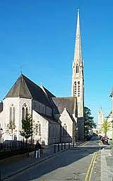

We celebrate the Dedication of our
Cathedral at Plymouth (1880) St Mary and St Boniface
on
22nd September

St Padre Pio – Feast Day 23rd September

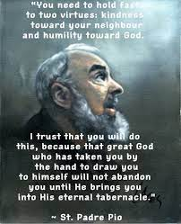

(contributed by Hilary)

*****************************************

Our Lady of Walsingham – Feast Day 24th September

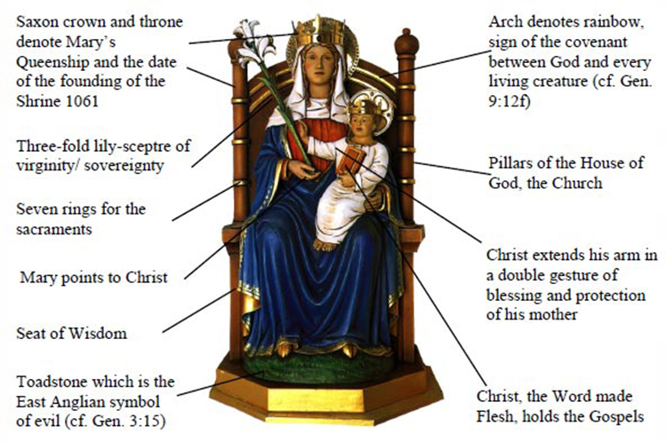
(contributed by Hilary)

ROMAN CATHOLICK CERTIFICATE
for places of worship
XXXI Geo.III [1791]
AT THIS COURT was Brought a Certificate That a certain Chapel situate and being in the Borough of Shaston otherwise Shaftesbury in this County is set apart for Publick Worship by Persons professing the Roman Catholick Religion and it was desired this Court would enter the same on Record.
ORDERED,
That the said Certificate be recorded accordingly.

[similar certificates were submitted and granted for chapels at East Lulworth, Stapehill, and Marnhull. I have not yet traced any for Blandford]

AT THIS COURT came Thomas Weld of Lulworth in the said County of Dorset Esquire and then and there in open Court between the Hours of Nine in the Morning and Two in the afternoon did make and subscribe the Declaration and Oath [illegible]tioned and contained in a certain Act of Parliament made and passed in the Thirty first Year of the Reign of the present Majesty King George the Third, intitled "An Act to relieve upon Conditions and under Restrictions the Penalties and Disabilities to which Papists or Persons professing the Popish Religion are by Law subject."
The like Certificate was granted John Wright of Steepleton Preston Esqre
The like Certificate was granted Thomas Stanley of Lulworth Castle Priest
The like Certificate was granted Alexander Clinton of the same Priest
The like Certificate was granted William Wilkinson Fletcher of Steepleton Priest Priest
The like Certificate was granted Edward Nickell of Wardour Castle Wilts Priest
The like Certificate was granted Samuel Luke Angier of Shaston Gent
The like Certificate was granted Frances Angier of the same Wife of Sam. Luke Angier
The like Certificate was granted Mary Walker of Shaston Spinster
The like Certificate was granted Juliana Macauley of the same Servant
The like Certificate was granted Peter Capel of the same Servant
The like Certificate was granted John Stanley of Marnhull Priest
The like Certificate was granted Ruth Mullett of Shaston Spinster
The like Certificate was granted Grace Mullett of Shaston Spinster
The like Certificate was granted Jane Haylock of the same Spinster

[Dorset Quarter Sessions Order and Plea Books Midsummer 1791 reference no. QSM 1/11, Dorset History Centre Dorchester]

(contributed by Avis)

