22 August 2021 Divine Office: Week 1
OUR LADY OF LOURDES AND ST CECILIA

Parish Administrator: Mgr. Francis Jamieson
Landline: 01258 452051 Mobile: 07826 732493
Hospital RC Chaplains:
Dorchester: Fr. Barry Hallett 01305 255198, Poole: Deacon Declan McConville 01202 442167
Newsletter: newsletterblandfordcatholics@yahoo.co.uk
website:: blandfordcatholics.org

21st WEEK IN ORDINARY TIME YEAR B1
Please keep in your prayers:
Keith Wareham; Brendan Hewson;
Father Tom and all at the Care Home where he is Chaplain;
David Walker; and all families of those suffering at this time.
You will be pleased to know that Father Chacko and Canon Webb are recovering well.

MASS INFORMATION CORRECT AT THE TIME OF PUBLISHING BUT MAY BE SUBJECT TO CHANGE AT SHORT NOTICE
Saturday August 21
St Pius X, Pope (Mem)
9.30am HOLY MASS (EF)
5.30pm HOLY MASS of Sunday
Sunday August 22
7.30am, 9am (Children's Mass) No 10.30am Mass
Monday August 23 9.30am HOLY MASS St Rose of Lima (Opt Mem)
Tuesday August 24 NO MASS ST BARTHOLOMEW APOSTLE, FEAST
Patron of plasterers, tanners and leather-workers
Wednesday August 25 NO MASS St Louis of France (Opt Mem)
Patron of French monarchy and military barbers
and St Joseph Calasanz (Opt Mem) Patron of Catholic schools
Thursday August 26 NO MASS Bl Dominic of the Mother of God (Opt Mem)
Friday August 27 9.30am HOLY MASS St Monica (Mem)
Patron of alcoholics, difficult marriages, mothers, victims of unfaithfulness and widows
followed by Benediction
Saturday August 28
St Augustine Doctor of the Church (Mem) Patron of theologians, printers and brewers
9.30am HOLY MASS (EF)
5.30pm HOLY MASS of Sunday
Sunday August 29
7.30am, 9am (Children's Mass), 10.30am

This Sunday, August 22nd. there will be no Mass at 10.30, only at 7.30 and 9 in the morning. The day of the 1st. Communion Mass (September 5th.) will be the last day we have 3 Masses on Sunday morning. From the week-end after, Sunday, September 12th, we shall return to the 5.30pm on Saturdays and 9am on Sundays.

We shall keep enhanced hygiene, cleaning, and safety measures in place, so, as before, you will find sanitiser instead of Holy Water, and “Track and Trace” forms at the church entrance. We should continue to wear masks in church and, although singing is now allowed, it might be best to restrict it to the Alleluia, which should always be sung anyway.

There will be Benediction following Mass on Fridays from now on unless otherwise indicated.

ACCORDING TO GOVERNMENT ADVICE (QR.POSTER.SERVICE@NOTIFICATIONS.SERVICE.GOV.UK) WE ARE ASKED TO CONTINUE SIGNING-IN AT SERVICES AND MEETINGS IN CHURCH.

JOURNEYING FROM DESPAIR TO HOPE… PRISONS WEEK ONLINE EVENT
12 OCTOBER 2021 5-6.15PM Caritas Plymouth would like to invite you to an online event to explore the challenges facing prisoners and their families and how we can take action in our parishes. Prisoners and their families are often some of the most socially excluded people in our society. Even for people of faith they are often forgotten or come lower down on a list of causes to support. This event will include speakers from PACT and prison chaplaincy. It will offer an opportunity to direct our thoughts and prayers to prisoners, their families and children and to reflect on how we as individuals, as a Church and as a community are serving those affected by imprisonment.
You can register here https://forms.office.com/r/J1zTkUTiP7 or by emailing
Caritas@prcdtr.org.uk

WEEKLY OFFERINGS - £177.09. Thanks to all who contributed
FINANCIAL ACCOUNTS - The accounts for years ended 31 March 2020 and 31 March 2021 have now been approved by the Finance Committee. If you would like an electronic copy of either year accounts please contact me and I will send a copy to you :- ruthhiscock@cbeeches.co.uk I will leave copies of both years of the accounts as soon as I am able to leave papers at the back of the church. Ruth, Parish Treasurer

With blessings on every one of our parish family.

Father Francis

THE MAIN ONLINE CHURCHES WE USE ARE:
St. Bede's, Basingstoke www.stbedesbasingstoke.org.uk
St. Mary of all Angels, Worthing https://www.stmaryoftheangels.org.uk/
Our Lady, Star of the Sea, Weymouth. https://www.ourlady-starofthesea.com/
Also: www.churchservices.tv This website gives the times of all Church Services (Mass, Exposition, Holy Hour etc.) at many churches in UK and Ireland from 5.30am until 9.15pm. Tom and Teresa
The following links are also to churches and chapels who are currently streaming live Masses and other services:
LIVE ADORATION FROM TYBURN CONVENT: https://adoration.tyburnconvent.org.uk
There is a webcam in the GROTTO IN LOURDES (just google the words webcam, Lourdes and grotto) and Masses, the recitation of the Rosary and other prayers can be seen there throughout the day. There is a list on their website giving the details of which languages are used at which times. WESTMINSTER CATHEDRAL is now streaming live some Masses and services - please visit the Cathedral's website for further information and future schedules.
www.cpg.church takes you to GUILDFORD PARISH CHURCH website, where there are links to live-streamed Masses and other devotions online (thanks to Ann, Michael and Lynette for this)
BUCKFAST ABBEY The Abbey (now reopened with some restrictions) is livestreaming Mass. You can view these services on YouTube and Facebook.
And here is a link useful to those who are Deaf or hearing-impaired:
SIGNED MASS The parish of Our Lady and St Vincent in Potters Bar, Hertfordshire, is providing a Sign Interpreted Mass for its Sunday Vigil – 6pm every Saturday. You can watch here.

ANY OTHER BUSINESS
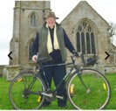
RIDE AND STRIDE is taking place this year on Saturday 11th September. The challenge is to walk, cycle, or scoot to as many local churches as possible, raising money for the Dorset Historic Churches Trust. Half of the money we raise comes back to our own church.
If you are interested in taking part, please get in touch with me and I can give you all the info you need. Perhaps we could create a joint parish justgiving page.
One of the nicest things about the day is being greeted at the different churches, sometimes with tea and cake! It would be great if we could also have volunteers to greet cyclists/walkers at our church. It's a chance for our church to be a visible presence in our town. Please let me know if you would be happy to help out with this, any time between 10am and 6pm, even just for an hour although 2 hrs would be great! Volunteers for cake or biscuit baking would be most welcome too!
If you want to get involved either in cycling, walking, volunteering or baking, please get in touch, 07729 139439 or alisoncain@gmail.com. Thanks, Ali

ASSUMPTION DAY BARBECUE Thank you to all those who attended the barbecue and to all those who assisted and worked so hard both on the day itself and in the lead-up to the event. Thanks too for the very generous donations of bottles, raffle prizes, cakes and plants. Not only was the event a wonderful opportunity for us to get together as a parish after the various lockdowns and the impacts of the pandemic, but it also raised £972 in support of the Blandford Welcome Group, which is a project run by a group of parishioners who are working towards resettling a refugee family in Blandford, through the Community Sponsorship Government Scheme. This is even more apt now, as we look around the world and view what is happening, particularly in Afghanistan and Syria. Should you wish to be part of the group or wish to find out more, please contact Anthony Reed (451132). A number of bottles were left un-won or too late to include from the bottle stall. These will be raffled either separately or as part of a future event. We will keep you updated of future events. Anthony

This week we had an inspection as a first step to try to arrest the process of spreading damp in the church and presbytery, using what seemed to be very sophisticated electronic equipment. At the end of the morning we were congratulated on the quality of the air in the church, free-flowing and free from pollution, so thank you all who are attentive to doors and to seeing to the benches after each Mass. Father Francis

Winners of the Sweepstake draw at the Garden Party last Sunday were: 1st Prize - £100 – Bernie Mizzi; joint 2nd Prize winners £25 each - Madeleine Hughes and Ruth Hiscock. Congratulations to the winners and many thanks to all who participate. It truly is much appreciated. Mike

We welcome contributions to this newsletter from parishioners; please send in links to websites, hard copy, email pictures, prose or poetry, whether to inform or to entertain....
"It is futile to make happiness a goal; it is always and only a by-product."
- Alice Thomas Ellis, Serpent on the Rock
(contributed by Avis)
***********************************

"I hold that Mary is now with Christ and in Christ. She is in Christ, because 'in Him we live and move and have our being'. She is with Christ, because she has been assumed into glory."
- St Augustine
(contributed by Hilary)

********************************************************
“As Scripture says, ‘Those who instruct many in justice will shine as stars for all eternity.’ They will attain this more easily, if they make a covenant of perpetual obedience and strive to cling to Christ and please Him alone."
- St Joseph Calasanz
(contributed by Hilary)
******************************
"It seems to me the most absurd thing in the world to be upset because I am weak and distracted and blind and constantly make mistakes! What else do I expect! Does God love me any less because I can’t make myself a saint by my own power and in my own way? He loves me more because I am so clumsy and helpless without him—and underneath what I am he sees me as I will one day be by his pure gift and that pleases him—and therefore it pleases me and I attend to his great love which is my joy."
- Thomas Merton, The sign of Jonas
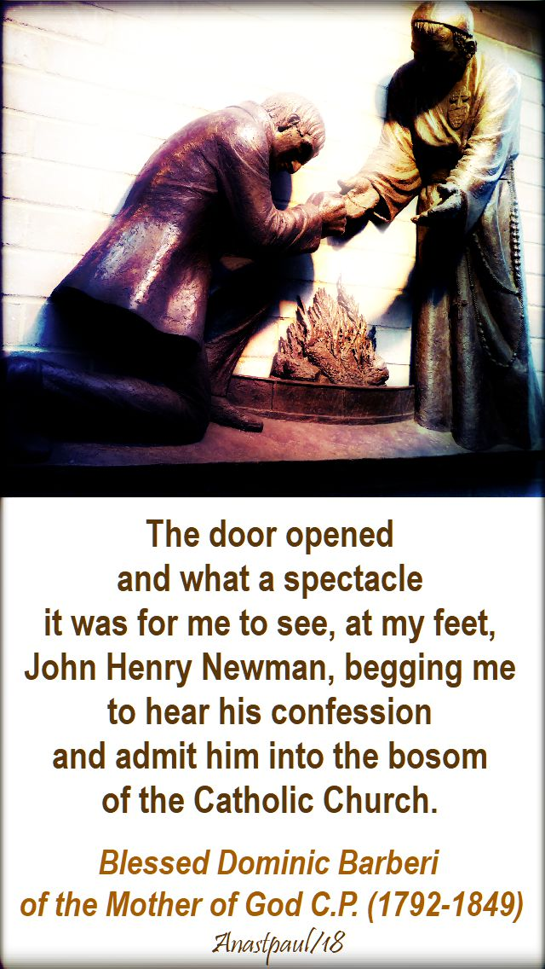
(contributed by Madeleine)

