VISIT TO THE SHRINE OF ST CANDIDA (ST WITE)

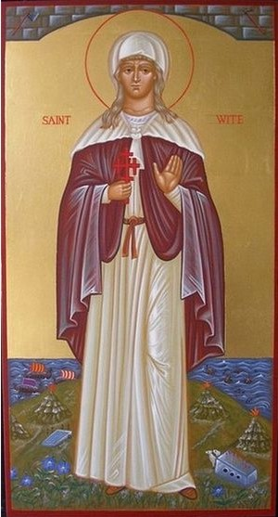
The Reverend Virginia Luckett, in charge of the parish of St. Candida & the Holy Cross, Whitchurch Canonicorum, has said that we are welcome to go to the shrine of St. Candida (St. Wite) to celebrate Mass and say our prayers to the saint. Whitchurch Canonicorum is just off the main road between Bridport and Honiton, about an hour away.

St. Candida - candida is the Latin for white, so in English St. Wite - was an Anglo-Saxon saint. There was an Anglo-Saxon church on the spot until Norman times, when a stone church was built. Little is known about St. Wite, but it is believed she was an anchoress (hermit) who lived nearby in Charmouth and was martyred by the Danes who plundered and killed Christians. Her relics are still there in the church in a 13th. century shrine, and with those of St. Edward the Confessor in Westminster Abbey, they are the only pre-Norman Conquest shrines with the relics intact which survived the Protestant Reformation in England.

There is a holy well not far away, and she was always invoked by those suffering from ailments of the eye.

I thought it would good for us to make a pilgrimage, having Mass in the church where her shrine is at, say, 12 noon and a picnic, and a walk to her well. We could leave at 10 and be back in the afternoon.
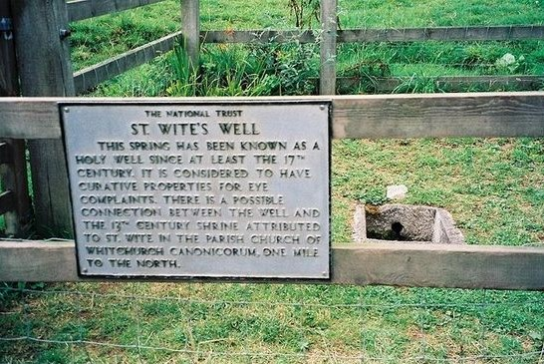
Would anyone like to come? The important thing is to fix a date. If you would like to come, please let me know on Saturday or Sunday whether you would prefer a Saturday or a week-day and if there are any dates impossible for you. I’ll get in touch with the Reverend Luckett as soon as possible and make sure we are booked in, as it were.

I am too old to be allowed to drive a minibus. If anyone young enough to be permitted could agree to take us, that would be good. If not I am sure we can manage in a few cars. Father Francis

an icon of St Wite and St Wite's Well

A Few Thoughts on Masks

Today I read that yet again over 100 people had died from covid and the infection rate continues to rise. In the supermarkets and other shops most people are wearing masks although the government has made it a matter of choice. We may well have to learn to live with covid, but at the moment we face an uncertain autumn when an already beleaguered NHS may face another crisis. What might we do about masks in church?

Here are some considerations:

It remains possible to infect someone standing nearby with covid, and a mask lessens the risk. The person next to you may have a serious illness or have a partner at home who is clinically vulnerable.
Anyone next to you may be very anxious about covid, and then the kind action is to wear a mask to help allay those fears.
If others are fearful, then it is hard for them not to be distracted during worship: again, we would want to do all we can to spare them that.

In a nutshell, wearing a mask cannot harm you, but not wearing one may certainly cause distress to others.

In September we are returning to only two Masses at the weekend. So the church will be fuller and we will have to be much closer to each other. When we make the responses, and especially when we sing, droplet spread will be very much greater if unmasked. Please, for the sake of those who remain anxious, let us put aside our personal preferences and choose to do all we can to help others feel safe.

Madeleine

