18 July 2021 Divine Office: Week 4
OUR LADY OF LOURDES AND ST CECILIA

Parish Administrator: Mgr. Francis Jamieson
Landline: 01258 452051 Mobile: 07826 732493
Hospital RC Chaplains:
Dorchester: Fr. Barry Hallett 01305 255198, Poole: Deacon Declan McConville 01202 442167
Newsletter: newsletterblandfordcatholics@yahoo.co.uk
website:: blandfordcatholics.org

ORDINARY TIME YEAR B1
Please keep in your prayers:
Keith Wareham; Father Chacko; Father Tom and all at the Care Home (unfortunately Covid has returned there);
Canon John Webb; and all families of those suffering at this time.

MASS INFORMATION CORRECT AT THE TIME OF PUBLISHING BUT MAY BE SUBJECT TO CHANGE AT SHORT NOTICE

Saturday July 17
9.30am HOLY MASS (EF)
5.30pm VIGIL MASS OF SUNDAY
Sunday July 18 CHILDREN'S MASS at 9 am
7.30am, 9am, 10.30am
Monday July 19 9.30am HOLY MASS St Apollinaris (Opt Mem)
Tuesday July 20 6.30pm HOLY MASS
Wednesday July 21 9.30am HOLY MASS St Lawrence of Brindisi (Opt Mem)
Thursday July 22 9.30am HOLY MASS ST MARY MAGDALEN (FEAST)
Friday July 23 9.30am HOLY MASS ST BRIGID OF SWEDEN (FEAST)
Saturday July 24
9.30am HOLY MASS (EF)
St Sharbel Makhluf (Opt Mem)
5.30pm VIGIL MASS OF SUNDAY
Sunday July 25 CHILDREN'S MASS
9am

FROM JULY 19, WE ARE FREE TO MAKE OUR OWN RISK ASSESSMENTS ABOUT SOCIAL DISTANCING, MASKS AND HAND SANITIZERS.
From July 25, unless another U-turn occurs, there will be no more 7.30am and 10.30am Mass on Sunday mornings, only one at 9 o’clock.

First Confessions and First Holy Communions
At a meeting of parents of the children who should receive their first Holy Communion this year (seven of them), we decided that we shall begin their instruction on Sunday, July 18th.
Each Sunday 9 o’clock Mass (and soon we hope that, with many restrictions being lifted, the only Mass celebrated on a Sunday will be at that time) will be a Children’s Mass, given over to helping our children understand what they are doing.
I should like the first 4 Sundays to be a preparation for their 1st. Confession, which will take place in August, and the second 4 Sundays a preparation for their 1st. Communion.

FATHER CHACKO is recovering well at home and is being looked after by parishioners and friends.

EVC UGANDA APPEAL - During June you generously gave £211.27. As there is now a surplus for Jackline’s education we have asked that the surplus money be retained for her future educational needs and equipment.
STANDING ORDERS - Amounts for June - Gift Aided £1,602.50, Non Gift Aided £100.00. Thank you. WEEKLY OFFERINGS - £226.00. Thanks to all who contributed. Ruth, Parish Treasurer

With blessings on every one of our parish family.

Father Francis

St Apollinaris, died 79 AD. Patron of epilepsy and gout.
St. Apollinaris was one of the first great martyrs of the church. He was made Bishop of Ravenna by St. Peter. The miracles he conducted in Ravenna soon attracted official attention, for they and his preaching won many converts to the faith. However, at the same time, his words and works brought upon the fury of the pagan people who beat Apollinaris cruelly on several occasions.
During one beating, Apollinaris was cut with knives, and scalding hot water poured over his wounds, then put on a ship to be sent to Greece.
In Greece the same course of preachings, and miracles, and sufferings continued. In fact, after a cruel beating by Greek pagans, he was sent back to Italy.
When Emperor Vespasian issued a decree of banishment against the Christians, Apollinaris was kept hidden for some time, but as he was leaving, passing through the gates of the city, he was attacked and savagely beaten. He lived for seven days, foretelling that the persecutions would increase, but that the Church would ultimately triumph. (Catholic News Agency)
St Bridget of Sweden In 1372, St Bridget visited the royal court at Naples. There, with a spirit reminiscent of Jeremiah, she prophesied the following warning, and priests proclaimed it from every pulpit. Bridget spoke for Christ: O my enemies, why do you so bodly commit such sins and do other things contrary to my will? Why have you neglected my passion? Why do you not attend in your hearts to how I "stood" naked on the cross and cried out, full of wounds and clothed in blood?
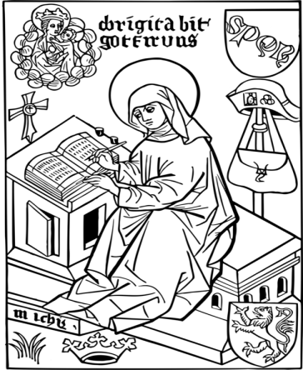
But your eyes and hearts forget and neglect all these things. And so you behave like prostitutes, who love the delight of the flesh, but not its offspring. For when they feel a living infant in their womb, at once they procure an abortion so that without losing their fleshly pleasure, they may always engage in their foul intercourse. This is how you behave. For I, God, your Creator and Redeemer, visit all with my grace, knocking at your hearts, because I love all. But when you feel in your hearts any knock of an inpouring of my Spirit or any compunction, or when through hearing my words, you conceive any good intention, at once you procure spiritually an abortion. You excuse your sins, delight in them and are even damnably willing to persevere in them. For that reason, you do the devil's will, enclosing him in your hearts and expelling me in this contemptible way.
My mercy, however, is that none of my enemies is so thorough or so great a sinner that I would deny him my forgiveness if he were to ask for it humbly and wholeheartedly.
Such revelation flowed through Bridget like a river. She prophesied condemnation and guidance to popes, kings, and nations. Individuals queried her about their spiritual state, and she spoke God's answers to them. (from The Times Book of Saints)

THE MAIN ONLINE CHURCHES WE USE ARE:
St. Bede's, Basingstoke www.stbedesbasingstoke.org.uk
St. Mary of all Angels, Worthing https://www.stmaryoftheangels.org.uk/
Our Lady, Star of the Sea, Weymouth. https://www.ourlady-starofthesea.com/
Also: www.churchservices.tv This website gives the times of all Church Services (Mass, Exposition, Holy Hour etc) at many churches in UK and Ireland from 5.30am until 9.15pm. Tom and Teresa
The following links are also to churches and chapels who are currently streaming live Masses and other services:LIVE STREAMING OF HOLY MASS - YOUTUBE LIVE Plymouth Cathedral is live streaming the Mass daily at 11am and an Evening Prayer will be posted at 4.30pm every day. The link is:https://www.youtube.com/watch?v=mUNt4x_nz0A (unfortunately the sound is not very good)
LIVE ADORATION FROM TYBURN CONVENT: https://adoration.tyburnconvent.org.uk
WALSINGHAM TIMES: https://www.walsingham.org.uk/live-stream/ and on youtube. There is a webcam in the GROTTO IN LOURDES (just google the words webcam, Lourdes and grotto) and Masses, the recitation of the Rosary and other prayers can be seen there throughout the day. There is a list on their website giving the details of which languages are used at which times. WESTMINSTER CATHEDRAL is now streaming live some Masses and services - please visit the Cathedral's website for further information and future schedules.
www.cpg.church takes you to GUILDFORD PARISH CHURCH website, where there are links to live-streamed Masses and other devotions online (thanks to Ann, Michael and Lynette for this)
Also the REDEMPTORISTS www.rpbooks.co.uk/holy-mass-online with Father Denis McBride, C.Ss.R. (thank you to Isobel for this).
BUCKFAST ABBEY The Abbey (currently closed to the public) is livestreaming Mass, Matins, Lauds, Vespers and Compline. You can view these services on YouTube and Facebook.
And here is a link useful to those who are Deaf or hearing-impaired:
SIGNED MASS The parish of Our Lady and St Vincent in Potters Bar, Hertfordshire, is providing a Sign Interpreted Mass for its Sunday Vigil – 6pm every Saturday. You can watch here.
ANY OTHER BUSINESS
- BARBECUE – ASSUMPTION DAY – SUNDAY 15 AUGUST A reminder of the barbecue taking place on the Feast of Our Lady’s Assumption on Sunday 15 August. Tickets will go on sale from this weekend (17/18 July). Ticket prices remain the same as they were 5 years ago ie £10 per adult and £5 per child (under 18). Tickets for third and subsequent children are free. Vegetarian tickets on sale too. Whilst this is a parish barbecue, friends and relatives are warmly invited to purchase tickets. As well as good food and good company, there will be a bottle stall (tombola), plant stall, raffle and the draw for the Parish Sweepstake. The bottle stall will comprise wine, spirits and soft drinks, together with non-drink bottles such as shampoo, sauces etc. We are looking for donations for both the bottle stall, the plant stall and the raffle, so if you have bottles or a plant you would be kind enough to donate or a nice prize for the raffle, please put them aside and we will make arrangements for them to be stored in the Church Hall in the weeks leading up to the event. Remember to pray for good weather too! Any proceeds following expenditure incurred will go towards the Blandford Welcome Group, which is a project of 30 or so of our parishioners who are looking to resettle a family from a war-torn country in the town, through the Government’s Community Sponsorship Scheme. Anthony .

CHILDREN’S WORKSHOP
Stop-frame animation workshop with Pageant Productions
10.00am– 3.00pm Tuesday 17th August 2021 in the Corn Exchange, Market Place, Blandford
Age group: 7 - 12
......Make your own Wallace and Gromit film! Pageant will provide arts, crafts and natural materials to make a scene that you can animate using stop motion. You’ll use a white box to build the scene, and Pageant provide all the necessary camera and computer equipment to do the animation.The day will begin with a workshop around storyboarding ideas and the basics of stop motion. Participants will then be split into groups to work on different elements of the story, making props, scenes and characters for the animation.
Tickets £10 Only 8 places available, from www.artsreach.co.uk
RIDE AND STRIDE
This fundraising event is taking place on Saturday 11th September and is a chance to cycle or walk to Dorset's beautiful churches and raise money for their upkeep. If you'd like to take part please contact Ali on alisoncain@gmail.com. More details to follow. Thanks, Ali

We welcome contributions to this newsletter from parishioners; please send in links to websites, hard copy, email pictures, prose or poetry, whether to inform or to entertain....

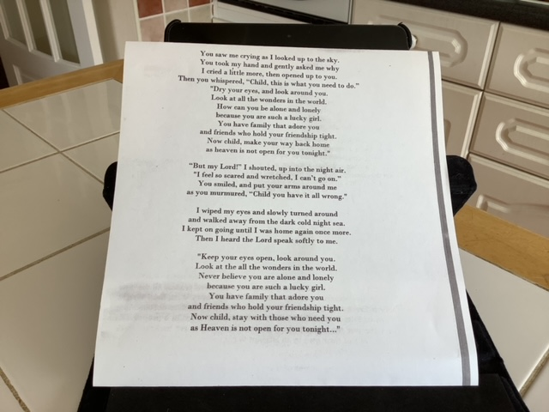
(contributed by Tom and Teresa)

***********************************************************

"It is with narrow-souled people as with narrow necked bottles: the less they have in them, the more noise they make in pouring it out."
- Alexander Pope
(contributed by Avis)
***********************************************************
St Mary Magdalene, teach us to forgive ourselves, and then to forgive others. Remove stubbornness and vengeance from our thoughts, cast out pride and vanity so that with confidence we may embrace goodness, humility and love; for nothing is sweeter than love. Amen.
- Saints
(contributed by Hilary)

"She [Catherine] saw Mary standing on a globe with rays of light flooding from her hands. ...'While I contemplated her, the Blessed Virgin lowered her eyes and looked upon me. Then I heard a voice saying to me: 'The ball that you see represents the entire world ... and each person in particular.' I cannot now express what I saw and felt. Oh! The beauty and the splendour of those rays! 'These rays symbolise the graces that I shed on those who ask for them.' With this I understood how agreeable to the Blessed Virgin are the prayers addressed to her. I discovered how generous she is toward those who invoke her, what precious graces she would give those who would ask them of her and with what joy she would grant them. ...' "
- St Catherine Labouré
(contributed by Hilary)

