9 May 2021 Divine Office: Week 2
OUR LADY OF LOURDES AND ST CECILIA

Parish Administrator: Mgr. Francis Jamieson
Landline: 01258 452051 Mobile: 07826 732493
Hospital RC Chaplains:
Dorchester: Fr. Barry Hallett 01305 255198, Poole: Deacon Declan McConville 01202 442167
Newsletter: newsletterblandfordcatholics@yahoo.co.uk

SIXTH SUNDAY OF EASTER YEAR B1

Please keep in your prayers: Jean Whittle, who has died recently, and her family.
Keith Wareham; Father Tom and all at the Care Home;
Graham Hemsley; Jen Toze; Canon John Webb; and all families of those suffering at this time.

MASS INFORMATION CORRECT AT THE TIME OF PUBLISHING BUT MAY BE SUBJECT TO CHANGE AT SHORT NOTICE

Saturday May 8 9.30am HOLY MASS (EF)
5.30pm VIGIL MASS OF SUNDAY
Sunday May 9 HOLY MASS SIXTH SUNDAY OF EASTER
7.30am, 9am, 10.30am
Monday May 10 9.30am HOLY MASS
Tuesday May 11 6.30 pm HOLY MASS
Wednesday May 12 9.30am HOLY MASS Ss Nereus and Achilleus, Martyrs; St Pancras, Martyr
Thursday May 13 THE ASCENSION OF THE LORD (OBL SOL)
Our Lady of Fatima (Opt Mem)
9.30am HOLY MASS
12 midday HOLY MASS (EF)
7pm HOLY MASS
Friday May 14 9.30am HOLY MASS ST MATTHIAS APOSTLE (FEAST)
Saturday May 15 9.30am HOLY MASS (EF)
5.30pm VIGIL MASS OF SUNDAY
Sunday May 16 HOLY MASS SEVENTH SUNDAY OF EASTER
7.30am, 9am, 10.30am

SOCIAL DISTANCING,
MASKS AND HAND SANITIZERS ARE STILL OBLIGATORY
Because of the covid situation in their area some dioceses, but not all, in the United States have decided to reimpose the obligation to attend Mass on Sundays and Holydays. Conditions in our country are different, and our bishops clearly think it is too early to make such a statement.

Ascension Day this year is on Thursday, May 13th. Remember that it is a Holy Day of Obligation, i.e. a day that the Church teaches us is as important as a Sunday and part of the minimum commitment for the practice of our faith. Mass will be celebrated at 9.30am, at 12 noon (in the Traditional Latin Rite), and at 7pm. We must remember that it is a serious sin - unless you are shielding or self-isolating - not to assemble to praise and thank God at Holy Mass on that day.
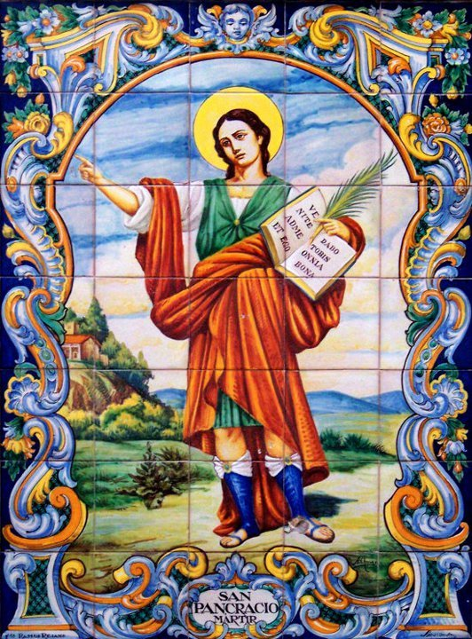

St Pancras, Martyr - Feast Day 12th May

PLEASE PRAY FOR the repose of the soul of Jean Whittle, who had died suddenly, and for her husband and family.

Alan and Maureen Wareham would like to thank everyone for their prayers for their son Keith; they seem to be working, together with chemotherapy, as his cancer on the liver has shrunk, therefore his life span has increased slightly. Please continue to pray for him. Thank you all very much.

DATE FOR YOUR DIARY May is Our Lady’s month and to celebrate, on 24th May which is the feast of Our Lady Mother of the Church, after Mass we will have Benediction and a decade of the Rosary.

Last Tuesday, May 4th., was the feast of the Martyrs of England and Wales, and at Mass we had the Litany of the Saints and Martyrs of England and Wales.
Have a look at the file of the same name which accompanies this newsletter; see the many saints who belong to us in England and Wales, and be proud. You may notice that 2 of them are in bold print, because their names are repeated twice as having special significance for us: St. Eustace White was arrested in Blandford and taken to London to be hanged, drawn, and quartered. St. Richard Reynolds was a Brigittine from the great Syon Abbey in Isleworth. He was hanged, drawn, and quartered in London too. The community of men and women of Syon Abbey had to take refuge abroad, and after many wanderings came back to England in 1861 when Catholics were again allowed to practise our faith. Their first house on their return was in Spetisbury, from where later they went to Chudleigh in Devon.
The Litany is long (again, thank God for these faithful men and women), but it would be good if you found a few moments to say it yourself in order to pray for the Catholic Church in our country.

The parish is immensely grateful to all donors who have supported the parish during the year and helped keep our doors open to achieve our Mission. If you don’t already do so, please consider whether you could increase the value of your donation by signing up for Gift Aid.
If you wish to Gift Aid your donation, Fr Francis has a supply of Gift Aid forms, please advise him whether you wish to give by Standing order and he will also give you a form to complete, or if the Envelope scheme, he will arrange for a supply of envelopes to be given to you.

GIFT AID DONORS - You should soon receive an individual statement of how much you gave in the year so that you can check you have paid enough tax to cover the gift aid that the parish will claim. This statement will go to the address that is currently held by the gift aid organiser. If you are expecting a letter but do not receive one please contact the Gift Aid Organiser Ruth Hiscock 01258 452283 or email ruthhiscock@cbeeches.co.uk. Thanks.

STANDING ORDERS Amounts for April: Gift Aided £962.50, Non Gift Aided £245.00. Thanks.

WEEKLY OFFERINGS All being well, we will restart counting in May and will publish the figures then. Ruth Hiscock Parish Treasurer

With blessings on every one of our parish family.

Father Francis

Judi Fawcett, who appealed in our church last month, has sent the details of a little girl our parish has sponsored in Fr. Boniface Kaayabula’s parish school in Masaka, Uganda.As you know, it will cost £20 a month to pay for her schooling, accommodation, and food, and the benefit to her is incalculable. Her name is Jackline Namatova, and we have a photograph for you to see. We must pray for Jackline, and also thank God that He has moved our hearts to show His love.
Jackline is the oldest of four children. Her father died and she is looked after by her widowed mother. The family lives in the slums of Masaka town. Her mother works as a maid for another family, but she is very poorly paid and so cannot manage to buy all the needs for home, as well as paying school fees for all four children.
Fr. Boniface came into contact with this family, and took Jackline to study at St. Matia Mulumba Primary School where she became a a boarder. She is now in Primary 6, is a good student and likes to study. She also likes to take part in reading the Scripture readings in church. It was likely that she would be asked to leave school, as Fr. Boniface had been helping her, but could not continue to pay her fees.
Sponsorship will mean that now she will know that her education can continue without interruption and that she can, hopefully, look forward to a much better future than the one her mother experiences.

THE MAIN ONLINE CHURCHES WE USE ARE:
St. Bede's, Basingstoke www.stbedesbasingstoke.org.uk
St. Mary of all Angels, Worthing https://www.stmaryoftheangels.org.uk/
Our Lady, Star of the Sea, Weymouth. https://www.ourlady-starofthesea.com/
Also: www.churchservices.tv
- This website gives the times of all Church Services (Mass, Exposition, Holy Hour etc.) at many different churches in UK and Ireland from 5.30am until 9.15pm. Tom and Teresa
The following links are also to churches and chapels who are currently streaming live Masses and other services:LIVE STREAMING OF HOLY MASS - YOUTUBE LIVE Plymouth Cathedral is live streaming the Mass daily at 11am and an Evening Prayer will be posted at 4.30pm every day. The link is:https://www.youtube.com/watch?v=mUNt4x_nz0A (unfortunately the sound is not very good)
LIVE ADORATION FROM TYBURN CONVENT: https://adoration.tyburnconvent.org.uk
WALSINGHAM TIMES: https://www.walsingham.org.uk/live-stream/ and on youtube.
There is a webcam in the GROTTO IN LOURDES (just google the words webcam, Lourdes and grotto) and Masses, the recitation of the Rosary and other prayers can be seen there throughout the day. There is a list on their website giving the details of which languages are used at which times. WESTMINSTER CATHEDRAL is now streaming live some Masses and services - please visit the Cathedral's website for further information and future schedules.
www.cpg.church takes you to GUILDFORD PARISH CHURCH website, where there are links to live-streamed Masses and other devotions online (thanks to Ann, Michael and Lynette for this)
Also the REDEMPTORISTS www.rpbooks.co.uk/holy-mass-online with Father Denis McBride, C.Ss.R. (thank you to Isobel for this).
BUCKFAST ABBEY The Abbey (currently closed to the public) is livestreaming Mass, Matins, Lauds, Vespers and Compline. You can view these services on YouTube and Facebook.
And here is a link useful to those who are Deaf or hearing-impaired:
SIGNED MASS The parish of Our Lady and St Vincent in Potters Bar, Hertfordshire, is providing a Sign Interpreted Mass for its Sunday Vigil – 6pm every Saturday. You can watch here.

ANY OTHER BUSINESS
THE BIBLE TIMELINE COURSE: understand the Bible from start to finish, the Old and New Testaments, with this FREE OF CHARGE, worldwide-famous course, delivered online LIVE, by Mauro Ianicelli. Unfortunately already part way through, it started at 7.00.pm on 7th April 2021 (Eight Wednesday evening sessions) (not zoom). Info and free registration: www.comeandsee.org (When you register, Mauro will email you with the link to the talks).
We’ve had this course in the parish, first with Deacon Michael and then Fr Francis. Marie

We welcome contributions to this newsletter from parishioners; please send in links to websites, hard copy, email pictures, prose or poetry, whether to inform or to entertain....

"Every man is guilty of all the good he did not do."
- Voltaire
(contributed by Avis)

*****************************************************

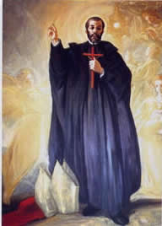
"Come here then, my soul, and tell me - in God's name, I ask you - what hinders you from following wholly after God with all your strength? What do you love if not God our spouse? Why don't you have great love for him who has so greatly loved you? Had he nothing else to do on earth except to give himself up for you? And seek your benefit even to his own hurt?
What is there to do on earth except to love the King of Heaven? Don't you see that all these things must come to an end? What do you see? What do you hear? What do you touch? Taste? Handle? Don't you see that all these things are but a spider's web that can never clothe you or keep you from the cold?
Where are you when you are not in Jesus Christ? What do you think about? What do you value? What do you seek beyond the one perfect good?
Let us rise, my soul, and put an end to this evil dream. Let us awaken, for it is day, and Jesus Christ, who is the Light, has come."
- St John of Avila (1500-69); feast day 10 May
(contributed by Hilary)

